for the
Jersey Skylands Labrador Retriever Club
Annual Holiday Meeting & Party
Tuesday, December 3, 2013 at 8:00pm
(following the 7:30 board mtg.)
The Parish House at St. John's Episcopal Church
226 Cornelia Street, Boonton, NJ (directions below)
All members are asked to bring a favorite dish for our
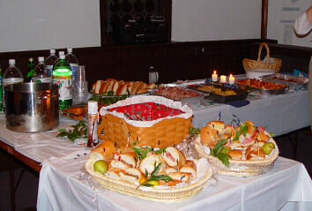 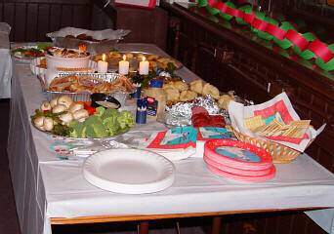
BUFFET of FINE FOODS
There will be the
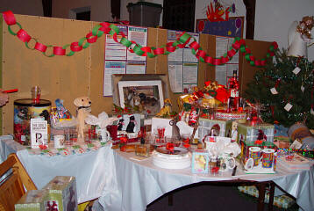 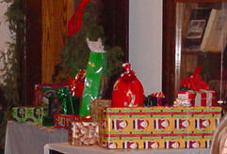
JSLRC RAFFLE and the DOG GRAB BAG

Any and all kinds of donations gratefully accepted!
Please bring a $10 Wrapped gift FOR A DOG TO EAT OR PLAY WITH

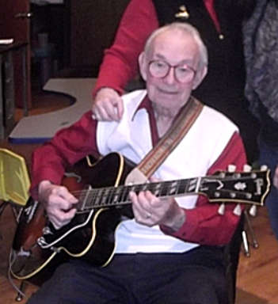
Live Music
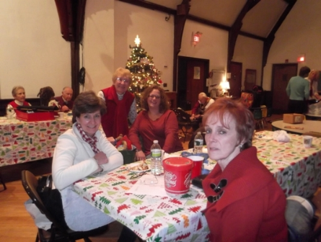 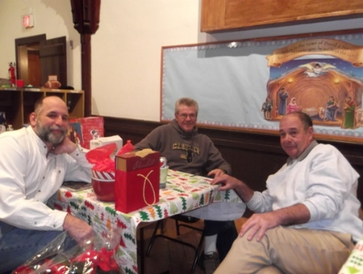 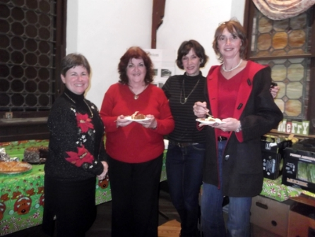
And Good Friends
Please RSVP to: Eve Ragalia 845-883-9143
windwoodkennels@aol.com
St. John's Episcopal Church ~ The Parish House
226 Cornelia Street, Boonton, NJ 07005-1712
The Parish House Entrance is on Cedar Street
Located on the corner of Cornelia & Cedar Sts.
Directions:

From Rt. 287 NORTHBOUND:
Take Exit 44 MAIN STREET BOONTON.
Turn RIGHT onto LATHROP AVE.
Turn RIGHT onto MAIN ST.
Make a RIGHT on CORNELIA ST.
(just AFTER the Post Office).
Make the 2nd LEFT onto CEDAR ST.
Building is on the LEFT - You enter from Cedar St.
Please park on the street.
From RT. 287 SOUTHBOUND:
Take Exit 45 MYRTLE AVE towards Boonton.
Turn LEFT onto MYRTLE Ave / Rt. 202
Turn RIGHT onto MAIN ST.
Make a RIGHT on CORNELIA ST.
(just AFTER the Post Office).
Make the 2nd LEFT onto CEDAR ST.
Building is on the LEFT - You enter from Cedar St.
Please park on the street.

