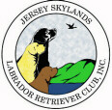 Skywriter 
Volume 2007, Issue 3 May/June 2007

Babes in Skyland
BREEDER REFERRAL LISTINGS
www.jerseyskylandslrc.com/BreederReferral.htm
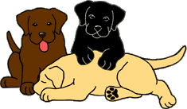

BABES ALREADY LANDED
5 ½ YEAR OLD CHOCOLATE FEMALE
Quiet, well-behaved, spayed.
Housebroken & crate trained. Travels well.
Gets along well with other dogs & cats.
OFA Hips Excellent, Elbows Normal, ACVO 2/06 Optigen A1
Karen Lolli 845-283-5725

19 MONTH OLD YELLOW FEMALE
Born: October 23, 2005
Spayed, housebroken current on all vaccines.
Gets along great with children and other dogs.
Petite and has a calm temperament.
Sire: Ch. Shadowbrook’s Just Ducky
OFA Hips Good, Elbows Normal, CERF, A1
Dam: Ch. Forestwood’s Purple Rain CGC
OFA Hips Good, Elbow Normal, Heart Clear
Leslie Plank 631- 724-7593 Forestwoodlabs@verizon.net

5 MONTH OLD CHOCOLATE MALE PUPPY
Born: January 9, 2007
Crate & leash trained. Current on puppy shots.
Sire: Ch. Lubberline Pumpernickle
OFA Hips Good, Elbows Normal, ACVO 08/06, Optigen B1
Dam: Blackwatch Olivia
OFA Hips Excellent, Elbows Norm, ACVO 02/06 Optigen A
Karen Lolli 845-283-5725

BLACK MALE PUPPY
Born: February 17, 2007
Has all shots & some training. Eyes ACVO Clear
Available as a pet.
Sire: Ch. Sureshot Hyspire Impressive
OFA Hips Good, Elbows Normal, OFA Heart ECHO, ACVO 09/06, Optigen Normal
Dam: Broadway’s Brooklyn
OFA Hips Good, Elbows Normal, Heart ECHO, ACVO 11/06, Optigen Normal
Maryann Czerwinski 973-534-7044
gemar@sprintmail.com
BLACK MALE PUPPY
Born: March 20, 2007
Do you have room in your heart and home for this little boy? This charming little guy is very sweet, very cuddly and very intelligent.
He was born prematurely, but, despite having underdeveloped legs at birth, he has learned to walk and play like any puppy and appears to be normal.
He comes when called, loves to play with his littermates, with his toys and with people.
He has been vet checked and has had his 1st shots.
Sire: Folklaur Homeport at Snugharbor
OFA Hips Good, Elbows Normal, Heart Cardiologist
CERF 2006, Optigen Normal by Parentage
Dam: Snugharbor Lady Pirate
OFA Hips Good, Elbows Normal, Heart Cardiologist
CERF 2004, Optigen A1
Gerri Kennedy snugharborlabs@sbcglobal.net
The breeders listed in our referral service are members in good standing of JSLRC, but under NO circumstance does JSLRC guarantee the services of said members. The buyer should review all contracts directly with the breeder.
Full members, eligible for additional benefits, wishing to list a litter in the club newsletter and on the website must do so in writing ON THE CLUB FORM.
Please send info to:
Laura Dedering - JSLRC Breeder Referrals
by email: jslrcinc@epix.net
by mail: 98 Ramblewood Dr. Bangor, PA 18013-5601

Table of Contents

President’s Message pg. 2
Point Show pg. 4
NJ Fed Of Dog Clubs pg. 5
Non-verbal signaling pg. 6
Point Show Ad pg. 9

JLRC Officers and Board:

President: Sharon Celentano

Vice Pres: Karen Lolli

Secretary: Donna Sevchuk
190 Asbury Anderson Rd
Asbury, NJ 08802
(908) 537-7041

Treasurer: Laura Dedering

Directors:
Ann DeGraw 2007
Laura Muirhead 2007
Donna Forte 2007

Newsletter Staff:
Newsletter Editor and Publisher:

Leslie Plank
Smithtown, NY
631-724-7593
forestwood@dellmail.com

Contributing Editors
and Publishers:

Gerri Kennedy-Youngblood
New Fairfield, CT
203-746-9432
Snugharbor@gowebway.com

Lisa Grasso
Merrick, NY
516-456-9400
lisag22@optonline.net

Laura Dedering
Bangor, PA
610-599-7767
LauraDedering@epix.net

SKYWRITER is a publication of the Jersey Skylands Labrador Retriever Club, Inc. published six times a year with deadlines on the 15th of Feb, Apr, Jun, Aug, Oct and Dec. Contributions in the form of articles, news comments, wins, litter, and other items of interest to the membership are encouraged. Opinions expressed are those of the individual authors and not those of the JSLRC either in whole or in part. The Editor reserves the right to edit materials in the interest of space, literary clarity, good taste or timeliness. All deadlines will be strictly enforced. Subscriptions are available to non-members for $12.00 per year from JSLRC, through the Publisher.


By Eleanor Palmieri

Committee Chairs are reminded to contact new members and get them involved in JSLRC activities.

Associate members who have been active for at least one year at our events are welcome to seek sponsorship and apply for Full membership.

Anyone interested in becoming a FULL or an ASSOCIATE member of JSLRC can contact our Membership Chair for procedures and a membership packet.
Call or write to
Eleanor Palmieri -
JSLRC Membership Chair

252-728-0755
EPALMIERI@ec.rr.com



PRESIDENT’S MESSAGE

Hi! Hope everyone has been enjoying some of the warm weather we have been having.

Our next General meeting will be on Wednesday, July 25th. This meeting is important because we will be discussing our September Back-to-Back Specialties being held for the first time with Tuxedo Park Kennel Club and Somerset Hills Kennel Club. Our new site is at North Branch Park in Bridgewater, NJ. It is a beautiful site with plenty of shade trees and well away from where the All-Breed show is being held. Maryann Czerwinski is the Chairperson of this event and still needs volunteers to help with our Specialty. In addition, we will be having a Supported entry at the same site the day before (Thursday, September 6th) with the Big Apple Sporting Dog Society.

Our Specialty “B” Match will be held on August 19th. The Match is always a lot of fun and a good way to socialize young puppies and prepare your dogs for the fall Specialties. Information on the match and other JSLRC events can be found on the club’s web site at www.jerseyskylandslrc.com

Have a great summer!

Sharon Celentano

Stars of the Sky

Brookberry’s Perfect Impression
Trenton KC- WD
3 point major!
Breeder/Owner/Handler: Donna and Stephanie Forte, Kathy Mines

Brookberry’s Charming Addition
Harrisburg KC, LRCP supported entry
WB – 3 point major!
Breeder/Owner/Handler: Donna and Stephanie Forte

Cole-Pop’s Perfect Thyming
LRCP – 3rd place 9-12 month sweeps black
Owner: Becky Poppiti and Karen Day

Hedgelawn’s Doc Holiday
LRC Of The Piedmont – BOS Sweeps
LRCP – 1st place 12-18 month chocolate
LRC Pioneer Valley Day 1 – BOS Sweeps
LRC Pioneer Valley Day 2 – WD/BOW
5 point major!
Breeder/Owner/Handlers: Tom and Tambra Flaherty

Woodhull’s On My Honor
Delaware Water Gap – WB/BOW
Breeder/Owner/Handler: Corey Anger

Beechcroft Woodhull Hallelujah
LRC Pioneer Valley Day 1- Best Veteran In Sweeps
LRC Pioneer Valley Day 2 – 1st place 7-9 veteran bitch
Owner/Handler: Corey Anger

Woodhull’s Brown To The Bone
LRC Pioneer Valley Day 1 – 1st place 9-12 Puppy
And Best Puppy!
Breeder/Handler: Corey Anger

Congratulations to our winners!

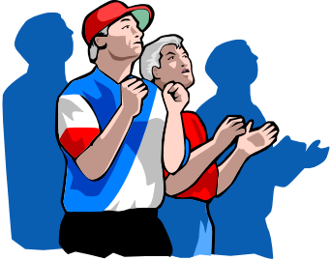

JUDGES 2008 SELECTION

Attention All Club Members if you would like to contribute names for the 2008 Judges Selection ballot please submit to me before July 15th via email to: gemar@sprintmail.com

At the July General Meeting we will have the 2008 Judges Selection Ballot and all members will be able to give their input. Please attend this meeting and help us select the upcoming judges. Thanks.

Judges Selection Committee

(S. Celentano, L. Dedering, M. Czerwinski)

Top 10 Reasons for Breeding Dogs

1. You think the house is too orderly.

2. You're already an insomniac.

3. You want your vet to buy a new BMW.

4. Your furniture looks too new.

5. You love the sound of puppies in the morning, noon, afternoon, evening, midnight, predawn, etc.

6. Your garden and backyard need renovating and you don't want to pay a landscaper.

7. Your neighbors don't complain enough already.

8. The kids aren't really a challenge.

9. If you can train and show one dog, why not ten?

10.You can't think of a better way to test your spouse's loyalty.

The following was submitted by Maryann Czerwinski, Point Show Chair:

The JSLRC Specialty shows in conjunction with Tuxedo Park KC and Somerset Hills KC are well into the execution plans. See our ad in Labrador Quarterly!

We now have added Big Apple Sporting Society (BASS) on Thursday, September 6th! JSLRC will support the entry for this show. The judges are Dan Ericsson/Raglan Labradors/Sweden and Puppy & Veteran Sweepstakes Dottie Black/HiView Labradors. The show will be on the same grounds as our two specialties and in the same area.

As plans proceed, I still find myself in need of hospitality people. Someone is needed to coordinate the food vendor and our Friday night after show get together. A food vendor will be in our area to provide lunch etc. so no one has to go any distance to the other part of the show for food. Would like someone to coordinate this process and handle the Friday night get together party.

My committees are as follows so far:

Trophies & donations | Gerri Kennedy Youngblood
Trophies (Day of Show) | Ann DeGraw
Grounds | Donna Forte & Frank Murch
Judges’ Gifts | Laurie Muirhead
Ring Decorations | Laura Jennings
Catalogs at ringside | Geri Mines
Education Table | Geri Mines
Raffle | Corey Anger
Event Sponsorship | Becky Poppiti
Hospitality | Needed

There are many of you who have volunteered to help but not chair a committee. We can always use the help and will be calling on you the days of the shows to help out with various tasks. Donna Forte will need a couple of people to be at the entrance gate early in am to show the Lab people where to park. Corey Anger will definitely need help selling raffle tickets. Ann DeGraw may need some extra hands with trophies.

Everyone is welcome to volunteer their help. I look forward to hearing from you. Just email me at: gemar@sprintmail.com.

The following was submitted by Stan Domozyk, our NJ Federation Of Dog Clubs delegate:

The New Jersey Federation of Dog Club delegates’ meeting took place on May 2, 2007, at the Holiday Inn in Somerset, New Jersey.

The Club President, Priscilla Gabrosch, addressed the group at the beginning of the meeting. The first issue she brought up was how to contact the Federation. She said all contact should be initiated through the Federation’s corresponding secretary, Audrey Wright. Ms. Wright’s phone number is 732 671-4341. Her email is . Ms. Gabrosch said that if she is forwarded correspondence from Ms. Wright, sent for her attention as Club President, Ms. Gabrosch said she will respond. She also stated however, that she does not like using email, and will respond only by phone or letter to any inquiry which she answers for the Federation. Anyone wanting to contact her must give their phone number or mailing address, in their email to the Federation’s corresponding secretary.

Ms. Gabrosch spoke about N.J. Assembly Bill A2820. This bill would stop insurance companies from canceling or denying coverage to a home owner, based on the breed of a dog kept on the premises. She said the bill had passed the Assembly and was now in the N.J. Senate. She requested everyone write their Senators to support this bill. Concerning this bill, Ms. Gabrosch did not mention, but the bill will allow an insurance carrier to issue a new policy ( I am assuming upon renewal of the policy), which can contain an exclusion for liability for any dog’s actions, or for certain breeds of dogs. Unfortunately I had not had the opportunity to view this bill before the meeting, so I could not point out this was also one of the bill’s provisions. This bill is essentially a two edged sword. They cannot cancel your policy, if there is coverage for a pet in it already. They can however, upon renewal, exclude that coverage, or limit it legally. The bill, if passed, stops insurance company refusals to insure, to cancel, or non-renew a policy based on the type of dog you own. It also however, allows them for refuse coverage specifically for your dog. The bill, S2102, can be viewed at www.njleg.state.nj.us/bills/BillView.asp. You will probably have to enter the Senate bill number to bring up the bill ( S2102 ).

The Treasurer’s report was given. The opening balance was $15,180.00. Debits to the account were $6,373.22. The Closing balance was $9,087.78.

The program for the night was the introduction of the proprietors of Wholistic Paws, an all natural dog food store. They mentioned the type of products they sell. They said their purpose was to offer nutritional alternatives. They are located at 215 Chestnut Street, Ridgewood, New Jersey, 07450. Their phone number is (201) 444-9911.

The Recording Secretary cast one ballot for the following slate of Officers and Board Members for the year 2007:

President: Priscilla Gabosch
1st V.P. Gerry Dalakian
2nd V.P. Joan Tabor
Treasurer Marie Gemeinhardt
Corresponding
Secretary Audrey Wright
Recording
Secretary Catherine Newsom

Board of Directors:
Rose DeMario-Bednarz
Jeffrey Ball
Donna Welty
Anthony DeMarzo

There was discussion concerning Assembly Bill A2649, which would re-write New Jersey’s criminal code statute as regards animal cruelty. Delegates present and myself, had a considerable floor discussion with Ms. Gabosch. It was Ms. Gabosch’s position that this bill had been a collaborative effort with Assemblyman Van Drew. While I agreed that Ms. Gabosch had evidently had certain items she wanted changed in the bill done, there seemed to be many items which I raised concern about in the bill of which she seemed totally unaware. This bill has gone through a second reading at this point. I strongly suggest everyone contact their Assemblyperson and express their concern regarding some of the provisions in this bill, which are mentioned in another section of the newsletter. Anyone wishing to read the bill can go to Once again you will probably have to enter the bill’s number ( A2649 ) to bring up the bill.

George Heintz suggested he would create a sample letter, which others could use to write to their assembly people about this bill and why it should be changed or voted down.

The meeting was adjourned after this discussion.

Stan Domozyk
N.J. Skylands LRC Delegate

How Animals Perceive the World: Non-Verbal Signaling
Karen L. Overall, MA, VMD, PhD, DACVB, ABS Certified Applied Animal Behaviorist

Introduction:
The uniting feature that connects all social vertebrates is the extent to which they signal non-verbally. Communication involving ritualized displays or graded signals is used to confirm or reject information received from others in social interactions, to indicate species, sex, and sexual receptivity, to signal about issues pertaining to status, and to otherwise negotiate all social interactions. As such, communication can involve such instantaneous behaviors as tactile and visual displays. These are relatively "short-distance" signals. Vocal communication is also instantaneous, but may reach over longer distances. Verbal communication is only one variety of vocal communication, and both of these may pale when the full story of olfactory communication is written. Certainly, olfactory and pheromonal signals provide information that can be assessed over distances and across time.
When assessing any communicatory structure it is important to realize that signaling involves a set of rules that will be shaped by the evolutionary history of the species. The story of canine domestication is the story of work and work-related tasks. The story of feline domestication is the story of rodent and vector borne diseases and their prevention. These 2 divergent paths to domestic life-styles have been shaped by, and in turn have continued to shape factors like reproductive schedules, fecundity, age at first reproduction, age at sexual and social maturity, composition of family or group units, and social interactions within these units. To understand such behaviors it is critical to understand the component signals as they are used to communicate with conspecifics. The following tables provide an introduction to this topic.

CANINE SIGNALS
Signal | Circumstance Information
barking | alerting/warning  attention-seeking
growling | warning  distance-increasing
crying  whimpering  whining | et-epimeletic
howling | elicit social contact  anxiety situations (social contact = reassure)
moans | pleasure, contentment
tail and ears up; forefoot in front of other | alert, ready to participate
direct gaze | challenge  confidence  absence of threat  distance-increasing
averted gaze | fear  cowardice  deference  absence of challenge (not the same as deference for confident, high-ranking dogs)  distance-decreasing signal
belly presented | deference - if neck, back, and other solicitation bues given  disengagement - if inguinal area and, or chest covered may become aggressive if pursued  relaxation - if flaccid
tail tucked when belly presented | fear/submission
tail tucked when belly presented with urination | profound fear/submission
grin | deference  distance-decreasing signal
piloerection | arousal associated with anxiety, fear, agression  distance-increasing
piloerection restricted to neck or tail region | confident dog
rigid stance, stiff torso musculature | confidence and intent to interact (may not be aggressive)  distance-increasing
tail above horizon | confident  high status
tail below horizon | less confident  lower status  deference  fear
tail wag | willingness to interact
tail tip wag; stiff | confident  assertive  offensively interactive
neck erect or arched | confident  challenging
ears erect | alert  confident
ears back | fear
ears vertically dropped | deference  submission  low rank  anxiety
snarl/growl with only incisors and canines apparent | confident  offensively aggressive  distance-increasing
snarl/growl with all teeth and back of throat apparent | defensively aggressive  fearful  distance-increasing
body lowered | defensive  distance-decreasing  fearful  deferential  relaxed
licking lips, flicking tongue | appeasement  et-epimeletic  distance-decreasing  anxious (and solicitation of reassurance; derived from et-epimeletic)
raising forepaw | distance-decreasing  solicitation of attention  deference (off balance)
paws out, front end down, rump up, tail wagging | body bow, invitation to play
perpendicular posture | challenge  confidence
mounting or pressing on back shoulders of another dog | challenge  marking, claiming
licking at corner of another dog's (or person's) mouth | et-epimeletic  deference  solicitation
blowing out lips/cheeks | anticipation (positive or negative)  anxiety (if very fast)
popping or snapping of upper and lower jaws (bill pops) | capitulation, intention to comply as a last resort

Subject: FOR ALL PET OWNERS
Dear Cats and Dogs,
The dishes with the paw print are yours and contain your food. The other dishes are mine and contain my food. Please note, placing a paw print in the middle of my plate and food does not stake a claim for it
becoming your food and dish, nor do I find that aesthetically pleasing in the slightest.
The stairway was not designed by NASCAR and is not a racetrack. Beating me to the bottom is not the object. Tripping me doesn't help because I fall faster than you can run.
I cannot buy anything bigger than a king sized bed. I am very sorry about this. Do not think I will continue sleeping on the couch to ensure your comfort. Dogs and cats can actually curl up in a ball when they sleep. It is not necessary to sleep perpendicular to each other stretched out to the
fullest extent possible. I also know that sticking tails straight out and having tongues hanging out the other end to maximize space is nothing but sarcasm.
For the last time, there is not a secret exit from the bathroom. If by some miracle I beat you there and manage to get the door shut, it is not necessary to claw, whine, meow, try to turn the knob or get your paw under the edge and try to pull the door open. I must exit through the same door I entered. Also, I have been using the bathroom for years -- canine or feline attendance is not mandatory.
The proper order is kiss me, then go smell the other dog or cat's behind. I cannot stress this enough!
All Non-Pet Owners Who Visit And Like to Complain About Our Pets
They live here. You don't. If you don't want their hair on your clothes, stay off the furniture (That's why they call it "fur"nature. I like my pets a lot better than I like most people. To you, it's an animal. To me, he/she is an adopted son/daughter who is short, hairy, walks on all fours and doesn't speak clearly. Remember: Dogs and cats are better than kids because:
- They eat less
- They don't ask for money all the time
- They are easier to train
- They usually come when called
- They never drive your car
- They don't hang out with drug-using friends
- They don't smoke or drink
- They don't worry about having to buy the latest fashions
- They don't wear your clothes
- They don't need a gazillion dollars for college, and...
MOST IMPORTANTLY .......
11. If they get pregnant, you can sell their children!

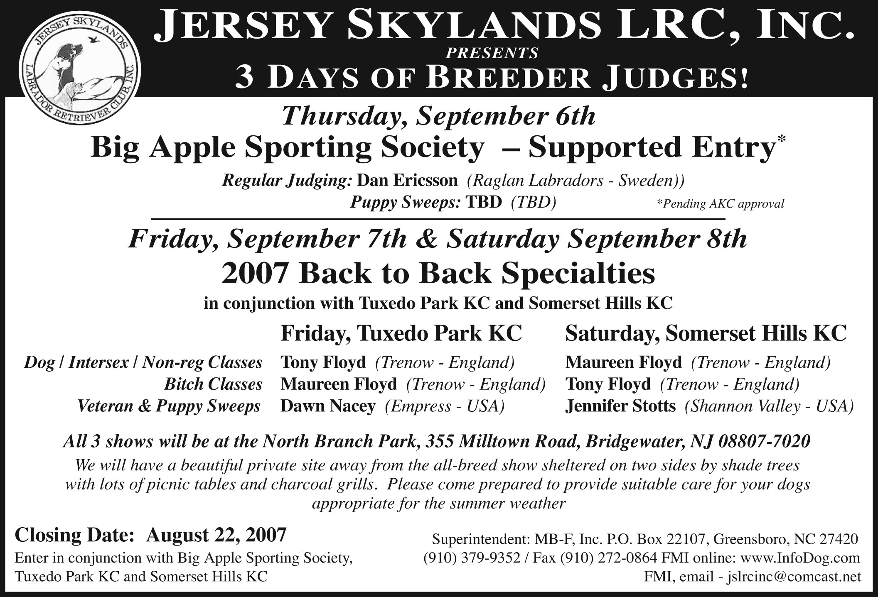
BIG APPLE SPORTING PUPPY & VETERAN SWEEPSTAKES WILL BE JUDGED BY DOTTIE BLACK, HI VIEW LABRADORS

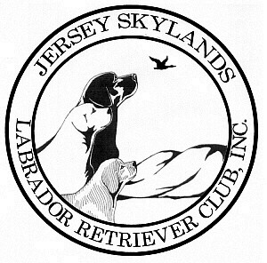
Jersey Skylands Labrador
Retriever Club Newsletter

Leslie Plank
Editor/Publisher
15 Thrush Drive
Smithtown, NY 11787

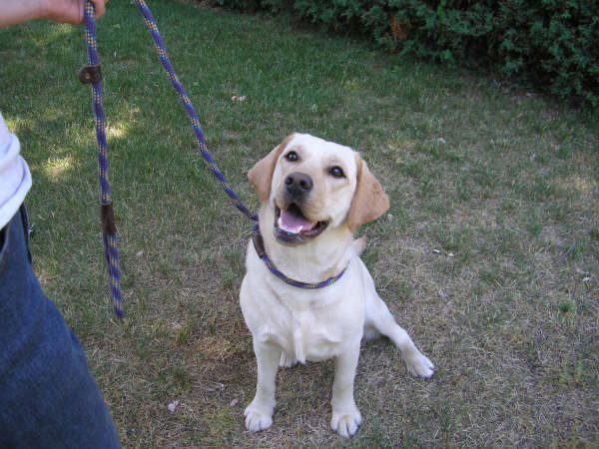

JSLRC Upcoming Events

July 25, 2007 Board Meeting 7:30 PM
General Meeting 8:00 PM
Agenda: Preparation for Specialty Shows

August 19, 2007 Labrador Specialty “B” Match Show
Labrador Specialty “B” Match Encore Show

Sept. 6, 2007 Supported Entry with Big Apple Sporting Society
Same site as our back to back specialty!

Sept.7 & 8, 2007 Back to back Specialty Shows
Held in conjunction with the Tuxedo Park KC
and Somerset Hills KC
Bridgewater, NJ

