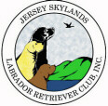 Skywriter 
Volume 2007, Issue 5 September/October 2007

Babes in Skyland
BREEDER REFERRAL LISTINGS
www.jerseyskylandslrc.com/BreederReferral.htm

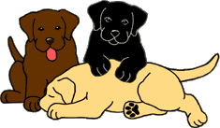

BABES ALREADY LANDED
5 ½ YEAR OLD CHOCOLATE FEMALE
Quiet, well-behaved, spayed.
Housebroken & crate trained. Travels well.
Gets along well with other dogs & cats.
OFA Hips Excellent, Elbows Normal, ACVO 2/06 Optigen A1
Karen Lolli 845-283-5725

SPECIAL NEEDS BLACK MALE PUPPY
Born: March 20, 2007
Do you have room in your heart and home for this little boy? This charming little guy is very sweet, very cuddly and very intelligent. He was born prematurely with a deformed elbow, but otherwise appears to be normal. He has adapted to his condition and plays like any other puppy. Raised in his breeder's home with young active children, he comes when called, loves to play with his toys, with people and other dogs. Leash and potty trained. Vet checked and has had 3 shots including Rabies.
We are willing to give this special guy to the perfect home. In exchange, we are asking that you assume the responsibility for his future care.
Sire: Folklaur Homeport at Snugharbor
OFA Hips Good/Elbow Normal, OFA Heart Cardiologist Clear, CERF 2006, Optigen NBP
Dam: Snugharbor Lady Pirate
OFA Hips Good, Elbow Normal, OFA Heart Cardiologist Clear, CERF 2004, Optigen A1
For more information on this special boy, please contact
Gerri Kennedy-Youngblood 203-746-9432
snugharborlabs@sbcglobal.net

YELLOW MALE AND FEMALE PUPPIES
Born: August 31, 2007
Sire: Ocean Spray Moby Dick JH
OFA Good, CERF 04/2006 Optigen Normal/Clear
Dam: Ancroft Skye's The Limit
OFA Good, Elbow Normal,
ACVO 11/2006 Optigen Normal/Clear
Ann DeGraw 908-362-5514
ancroft@earthlink.net

6 YEAR OLD NEUTERED BLACK MALE
Geo is the love of my life. He is a great companion,
besides being a great teddy bear who loves lots of hugs. Geo's joys are sharing my bed, going for car rides and swimming every day. It hurts me to place him for Geo would like to be the ONLY DOG.
Recently recovering from major surgery I do not have the strength if there is a problem with Geo with the other dogs. Geo is a love and still acts like a puppy but wants all the attention.
This is why he has to be the only dog
Eve Ragalia 845-883-9143
windwoodkennels@aol.com

3 1/2 YEAR OLD BLACK MALE
OFA Hips Good and Elbows Normal, Eyes CERF'd annually. Neutered. Up to date with all vaccinations. Housetrained and crate trained.
Good with other dogs. Very gentle, loves to play and please.
Hallie Sherck 914-302-2121
branwoodlabs@optonline.net
The breeders listed in our referral service are members in good standing of JSLRC, but under NO circumstance does JSLRC guarantee the services of said members. The buyer should review all contracts directly with the breeder.
Full members, eligible for additional benefits, wishing to list a litter in the club newsletter and on the website must do so in writing ON THE CLUB FORM.
Please send info to:
Laura Dedering - JSLRC Breeder Referrals
by email: jslrcinc@epix.net
by mail: 98 Ramblewood Dr. Bangor, PA 18013-5601

JLRC Officers and Board:

President: Sharon Celentano

Vice Pres: Karen Lolli

Secretary: Donna Sevchuk
190 Asbury Anderson Rd
Asbury, NJ 08802
(908) 537-7041

Treasurer: Laura Dedering

Directors:
1 Year - Ann DeGraw 2007-2008
2 Year - Laura Muirhead 2007-2009
2 Year - Donna Forte 2007-2009

Newsletter Staff:
Newsletter Editor and Publisher:

Leslie Plank
Smithtown, NY
631-724-7593
forestwood@dellmail.com

Contributing Editors
and Publishers:

Gerri Kennedy-Youngblood
New Fairfield, CT
203-746-9432
Snugharbor@gowebway.com

Lisa Grasso
Merrick, NY
516-456-9400
lisag22@optonline.net

Laura Dedering
Bangor, PA
610-599-7767
LauraDedering@epix.net

SKYWRITER is a publication of the Jersey Skylands Labrador Retriever Club, Inc. published six times a year with deadlines on the 15th of Feb, Apr, Jun, Aug, Oct and Dec. Contributions in the form of articles, news comments, wins, litter, and other items of interest to the membership are encouraged. Opinions expressed are those of the individual authors and not those of the JSLRC either in whole or in part. The Editor reserves the right to edit materials in the interest of space, literary clarity, good taste or timeliness. All deadlines will be strictly enforced. Subscriptions are available to non-members for $12.00 per year from JSLRC, through the Publisher.

By Eleanor Palmieri

The following New Member was voted in at the
Sept 26th meeting:

Mr. Philip Hess
24 Hilltop Road
Kinnelon, NJ 07405
(201) 274-6808
E-mail: Phess@Caldwell.edu

Sponsored by Donna Forte and Sherri Mattheis

Phil’s Special Interests are: Point Show Committees; Match Show Committees; Stewarding; Health Clinic Committees; Field/Hunting - Training/Tests; Therapy Dog Visits; Canine Good Citizen/Therapy Dog Tests.
~
Committee Chairs are reminded to contact new members and get them involved in JSLRC activities.

Anyone interested in becoming a member of JSLRC can contact our Membership Chair for procedures and a membership packet.
Call or write to
Eleanor Palmieri -
JSLRC Membership Chair

252-728-0755
EPALMIERI@ec.rr.com

Table Of Contents

President’s Message - Page 2
Membership News - Page 3
Point Show Report - Page 4
Match Show Report - Page 5
Match Show Results- Page 5
Long Haired Labs - Page 9
PRESIDENT’S MESSAGE
SLRC’S Specialty Match was held on August 19, 2007. I would like to thank Match Chair Elizabeth Henry and her husband, Robert Macan for the work they did on the match. It was very successful with tasty food and beautiful puppies. Judges Laura Muirhead and Traci Stintzcum did a wonderful job! The Match Results can be seen on our club web site.

In September, JSLRC’s Back-to-Back Specialties were held for the first time with Tuxedo Park KC and Somerset Hills KC at North Branch Park. In addition, JSLRC had a Supported Entry the day before with Big Apple Sporting Society. North Branch Park was a beautiful location to hold a Specialty. Despite the very hot weather, there was ample shade and parking for the exhibitors. Many of the dogs that won at the JSLRC Specialty have since gone on to win top awards at other Specialties. The Floyds were very impressed with the sportsmanship and comradery shown by the exhibitors. They also told me that our hospitality was among the best. It was high praise coming from judges who have judged all over the world.

I am so very proud of our members whose efforts made our shows successful. First, I would like to thank our Point Show Coordinator, Maryann Czerwinski and Assistant Coordinator, Laura Dedering for the many, many hours of hard work they put in. I would also like to thank the following members: Corey Anger – Raffle, Micki Beerman – Breakfast Hospitality, Pam Bellek-Welsh – Fund Raising, Ann DeGraw – Trophies, Stan Domozyk – Photography, Donna Forte – Breakfast Hospitality, Parking, Clean up, Maureen Foster – Results Boards, Lisa Grasso – Publicity, Laura Jennings – Ring Decorations, Gerri Kennedy – Trophies, Sherri Mattheis – Breakfast Hospitality, Parking, clean up, Gerie Mines – Education, catalogs, Results Boards, Kathy Mines – parking, trophies, Laura Muirhead – Judge’s Gifts and fund raising, Frank & Cathy Murch – Grounds, Parking, Sheree Paskert (with Laura Dedering) – Judges Hospitality, Donna & Gary Sevchuk – club equipment, Patty Snow – Trophy Table. I sincerely hope that I have not overlooked anyone. In addition, thanks to the efforts of Tom Flaherty, JSLRC finally has a beautiful club banner.

Thanks again to everyone who has worked so hard to make our events successful. I look forward to seeing many of you in the coming year at our upcoming meetings and events.
Sharon Celentano
Membership News

Submitted by Sherri Mattheis, Membership Chair

We would like to congratulate the following members who have earned Additional Privileges for the current Club year.

*Additional Privileges are earned for meeting attendance and work performed during the prior club year Sept 1, 2006 – Aug 31, 2007*

Congratulations and THANK YOU for all your hard work!

Corey Anger
Pam Bellek
Sharon Celentano
Maryann Czerwinski
Laura Dedering
Ann DeGraw
Stan Domozyk
Tambra Flaherty
Tom Flaherty
Donna Forte
Catherine Hunter
Laura Jennings
Gerri Kennedy
Karen Lolli
Sherri Mattheis
Gerie Mines
Laura Muirhead
Cathy Murch
Frank Murch
Leslie Plank
Eve Ragalia
Donna Sevchuk
Hallie Sherck

More Membership News

At the recommendation of the Membership Committee and with the approval of the Board, we are delighted to inform you that we have added a new benefit to the Additional Privileges, effective immediately.

A Breeder’s Directory page will be added to the club website. This directory would run for the current club year and be similar to the NJFDC Directory pages. It would list codes for areas of interest; i.e. conformation, obedience, field, other performance areas, etc.

The reasons for creating this Breeder’s Directory were:

- To add another benefit to encourage more members to work.

- So stud dog owners would be more encouraged to work in order to earn this privilege since they have no use for the regular Breeder Referral services.

- The Breeder Referral page only lists dogs available as pets, It does not list puppies available for show or other performance competition. This directory would give members other opportunities through the club website to get inquiries for these areas.

- Members who currently do not have a litter or dog to list could still get inquiries for future breedings by being in the directory.

Further information will be sent to you via the club email and on the Member Services page of the club website.



Stars of the Sky

Branwood’s Morning Sunshine Of Tabatha
JSLRC Day 1 – 2nd Ambred Bitch
Breeder/Owner/Handler: Hallie Sherck

Branwood Remembers Mariah The Wind
JSLRC Day 1 – 2nd BBE Bitch
JSLRC Day 2 – 3rd BBE Bitch
Breeder/Owner/Handler: Hallie Sherck

Cole Pop’s Thyme Is On My Side
Columbia KC 9/29 – WD/BOS
Columbia KC 9/30 – 1st AmBred
Owners: Becky Poppiti and Karen Day

Cole Pop’s Perfect Thyming
Columbia KC 9/29 – 1st 12-18/RWD
Columbia KC 9/30 – 2nd 12-18/RWD
Owners: Becky Poppiti and Karen Day

Cedar Creeks All That Jazz
Sussex Hills KC – RWB
Pocono Mountain KC – WB/BOW/BOS
Westbury KC – RWB
Breeder/Owner/Handler: Sherri Mattheis

Am/Can Ch. Rockycreek’s On The Road Again JH CD RN
JSLRC Day 1 – 1st Hunting Retriever Dog and BEST OF BREED!
JSLRC Day 2 – 1st Hunting Retriever Dog / JAM
Breeder/Owner: Kathy and Gerie Mines

Ch. Rockycreek’s Sweet Liberty
Big Apple Sporting Society – WB
4 Point Major!
JSLRC Day 1 – WB/BOW/ Best BBBE
4 Point Major!
New AKC Champion!!
JSLRC Day 2 – BEST OF BREED
Breeder: Kathy Mines
Owner: Kathy Mines and Sue Raynis

Stars of the Sky
(continued)

Am/Can Ch. Rockycreek’s Sweet Basil
JSLRC Day 1 – BOS Vet Sweeps
JSLRC Day 2 – BOS Vet Sweeps
Breeder/Owner – Kathy and Gerie Mines

Can. Ch. Folklaur Tattleteller
Sarnia KC #2 - WB/BW/BOB
Bluewater KC #3 - WB
New Brunswick KC #4 - WB
New Brunswick KC #5 - WB
NEW Canadian Championship!!

Folklaur Song and Dance Man
Suffolk County KC – WD/BOW/BOB
Westbury KC – WD/BOW/BOB
In Canada:
Sarnia KC #2 - WD
Bluewater KC #3 - WD, BOW
Breeder/Owner – Laura Dedering
Co-owner/Handler - Jackie DeAngelo

Forestwood Cedarbrook Luca Bella
PRLRC Day 2 – 2nd 12-18 bitch
PRLRC Day 2 – 2nd 12-15 sweeps
Breeder/Owner: Leslie Plank
Co-Owners: Nicole and Michael Santamaria

Ch. Shar- Jam’s Fashion Plate
JSLRC Day 1 – BOS
JSLRC Day 2 – JAM
PRLRC Day 2 – JAM
Breeder/Owner/Handler: Sharon Celentano

Brookberry’s Perfect Impression
Sussex Hills KC – RWD
Lehigh Valley KC – WD
Berks KC - RWD
Westbury KC – RWD
Breeders/Owners: Donna Forte, Kathryn Mines, Stephanie Forte

Cedarcreek Brookberry Mahogany Storm
JSLRC Day 1 - 1st 12-18 bitch
JSLRC Day 2 – 3rd 12-18 bitch
Westchester KC – RWB
Breeders: Sherri Mattheis & Tyler Mattheis
Owners: Sherri Mattheis, Stephanie Forte & Donna Forte

CH Brookberry's Storm Trooper, RN
JSLRC Day 1 – JAM
JSLRC Day 2 – JAM
Breeders: Geraldine Mines & Donna Forte
Owners: Donna Forte & Stephanie Forte

Rocky Creek Brookberry Storm
JSLRC Day 2 – 1st Veterans 9+
Breeders: Geraldine Mines
Owners: Donna Forte & Geraldine Mines

Woodhull’s On My Honor
PRLRC – 2nd open chocolate bitch
Suffolk County KC – WB/BOS
Breeder/Owner/Handler: Corey Anger

Brookberry's Wish Come True
JSLRC Encore Match – BOS
JSLRC Day 2 – 1st 9-12 sweeps
JSLRC Day 2 – 2nd 9-12 dog
Breeder: Donna Forte & Stephanie Forte
Owners: Susan Hess, Philip Hess & Stephanie Forte

WOW!!!



Point Show Report

We got through another JSLRC Specialty; after not having a show since 2005 it was like starting from scratch again.

New clubs, new grounds, new issues. But all in all it turned out pretty good.

I would have liked the weather a bit cooler. The site was lovely with shaded picnic grounds.

I want to thank all my committee people for their help. You all worked very hard. This is not an easy job. Don’t let anyone tell you otherwise. Hopefully, some of the glitches that we encountered will be rectified for next year.

Thank you all.

Maryanne Czerwinski
Point Show Chair

JSLRC Day 1

BOB: Ch. Rockycreek’s On The Road Again JH CD RN

BOS: Ch. Shar-Jams Fashion Plate

WD: Woodhull’s Roger That

WB/BOW: Rockycreek’s Sweet Liberty

JSLRC Day 2

BOB: Ch. Rockycreek’s Sweet Liberty

BOS: Ch. Lubberline Martingale

WD: Broadway’s Dirty Rotten Scoundrels

WB/BOW: Nycoma Way Tanza Simply Bella

For the complete results and critiques, see the club website:
http://www.jerseyskylandslrc.com/EventResults&Photos.htm

Match Show Report

Submitted by Elisabeth Henry, Match Show Chair

We saw lots of beautiful Labradors at our Sunday Match at Memory Park on Sunday, August 19. We want to thank everyone who came out and participated. Cloudy skies made it perfect weather for the pooches. Laurie Muirhead, our Morning Match judge, and Traci Stintzcum, our Encore Match judge, gracefully led handlers and canines through very full class lists.

Once again, thank you to our old friends for their continued support of our club and our sport. And a warm welcome to all the newcomers. We hope to see you and your fine animals again and again.

A special thank you to Sharon Celentano, Laura Dedering, Kathy and Frank Murch, Maryann Czerwinski, and Sherri Mattheis, without whose knowledge and hard work none of this would have happened. And, a very special thank you to the animals we celebrate for their beauty, heart and spirit.
Match Results
Morning Match Judge: Laurie Muirhead (Muirwood)
Puppy Dog Classes:
3-4 Puppy Dog
1. Rock Creek's River Explorer - Frank Murch, Stephanie Forte, Kathy Mines and Sarah Micciche
2. Beau - Jenn Van Schoick
4-6 Puppy Dog
1. Folklaur Neverending Story - Laura J. Dedering
2. Beechcroft's Pardon Me Sir - Mary Wiest
3. Hopbrook's Home Run - Beth Schweitzer
4. Thor - Dominique Kessler
6-9 Puppy Dog
1. ShadowGlen McDreamy - Sharon and James Celentano
9-12 Puppy Dog
1. Brookberry Wish Come True - Philip Hess
2. Brookberry's Wizard Of Beaufort – Tom & Barbara Collins & Donna Forte
3. Woody - Jennifer Van Schoick
Puppy Bitch Classes:
3-4 Puppy Bitch
1. Tops - Jennifer Van Schoick
4-6 Puppy Bitch
1. Folklaur Storybook Ending - Laura J. Dedering
2. Windyhill Hedgelawn Emmy Winner - Penny Bodine and Tom and Tambra Flaherty
3. Hopbrook's Ida Mae Too - Beth Schweitzer
6-9 Puppy Bitch
1. Broadway's A Taste Of Honey at Hawk Point - Donna Sevchuk
2. Shar-Jam Bauble - Sharon and James Celentano
3. Broadway's A View From The Bridge at Hawk Point - Donna Sevchuk
4. Shar-Jam's Serendipity - Maryann and Al Dello Russo
9-12 Puppy Bitch
1. Brookberry’s Dressed to Charm - Stephanie and Donna Forte
2. Jersey - Jennifer Van Schoick
3. HiView Tiffany at Ancroft - Ann DeGraw
BEST PUPPY IN MATCH BOS PUPPY IN MATCH
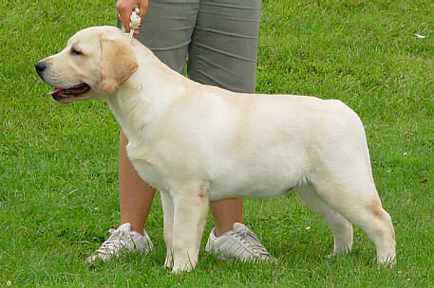 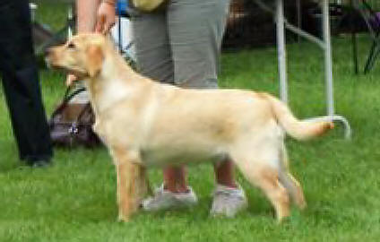
Folklaur Neverending Story Broadway's A Taste Of Honey At Hawk Point
Owner: Laura Dedering Owner: Donna Sevchuk
Adult Dog Classes:
12-18 Month Bitch
1. Soundview's Ripple in Still Water - Ellen Ingalls
Adult Bitch Classes:
12-18 Bitch
1. Cedar Creek's All That Jazz - Sherri Mattheis
2. Snowco's Shaken Not Stirred - Patty Snow
Bred By Bitch
1. Hedgelawn Holiday Spiced Kurry - Kim Edelheiser and Tom and Tambra Flaherty
Am Bred Bitch
1. HiView Beechcroft's Star Jasmine - Mary Wiest
Open Bitch
1. Tallmadges Playing with Fire - Sally Leary
2. Windyhill Tin Lizzie - Penny Bodine and Tom and Tambra Flaherty
3. Rosie - Jenn Van Schoick
4. Beechcroft's Study the Sea - Mary Wiest
Veteran Bitch 7-9 Years
1. Drifter Maidapromise at Hedgelawn - Tom and Tambra Flaherty
Veteran Bitch 9 Years and Older
1. Hemlock's Mad About You - Ann DeGraw
BEST ADULT IN MATCH: Hedgelawn Holiday Spiced Kurry
Owners: Kim Edelheiser and Tom and Tambra Flaherty
BOS ADULT IN MATCH: Soundview's Ripple in Still Water
Owner: Ellen Ingalls
JUNIOR HANDLER / BEST JUNIOR HANDLER
8-14 year
Erin Sharp
(handling Reuba owned by Jenn Van Schoick)
Encore Match Judge: Traci Stintzcum (Buttonwood)
Puppy Dog Classes:
3-4 Puppy Dog
1. Rock Creek's River Explorer - Frank Murch, Stephanie Forte, Kathy Mines and Sarah Micciche
4-6 Puppy Dog
1. Folklaur Neverending Story - Laura J. Dedering
2. Beechcroft's Pardon Me Sir - Mary Wiest
3. Hopbrook's Home Run - Beth Schweitzer
4. Thor - Jenn Van Schoick
6-9 Puppy Dog
1. Shadowglen McDreamy - Sharon and James Celentano
9-12 Puppy Dog
1. Brookberry Wish Come True - Philip Hess
2. Brookberry's Wizard Of Beaufort – Tom and Barbara Collins and Donna Forte
Puppy Bitch Classes:
3-4 Puppy Bitch
1. Tops - Jenn Van Schoick
4-6 Puppy Bitch
1. Windyhill Hedgelawn Emmy Winner - Penny Bodine and Tom and Tambra Flaherty
2. Folklaur Storybook Ending - Laura Dedering
3. Hopbrook's Ida Mae Too - Beth Schweitzer
6-9 Puppy Bitch
1. Broadway's A View From The Bridge at View Point - Donna Sevchuk
2. Broadway's A Taste Of Honey at Hawk Point - Donna Sevchuk
3. Shar-Jam's Bauble - Sharon and James Celentano
4. ArkAngels Paiselyn Plaid - Jenn Van Schoick
9-12 Puppy Bitch
1. HiView Tiffany at Ancroft - Ann DeGraw
2. Jersey - Jenn Van Schoick
3. Brookberry’s Dressed to Charm - Stephanie and Donna Forte
BEST PUPPY IN MATCH : Broadway's A View From The Bridge at Hawk Point
Owner: Donna Sevchuk
BOS PUPPY IN MATCH: Brookberry Wish Come True
Owner: Philip Hess
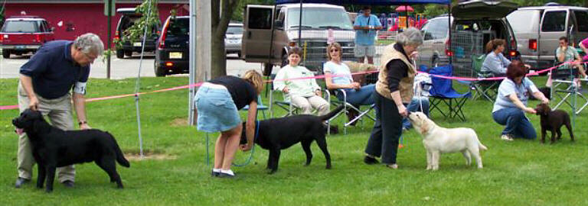
Adult Dog Classes:
12-18 Month Dogs
1. Soundview's Ripple in Still Water - Ellen Ingalls
2. Woody - Jenn Van Schoick
Adult Bitch Classes:
12-18 Bitch
1. Cedar Creek's All That Jazz - Sherri Mattheis
2. Snowco's Shaken Not Stirred - Patty Snow
Bred By Bitch
1. Hedgelawn Holiday Spiced Kurry - Kim Edelheiser and Tom and Tambra Flaherty
Am Bred Bitch
1. HiView Beechcroft's Star Jasmine - Mary Wiest
Open Bitch
1. Windy Hill Tin Lizzie - Penny Bodine and Tom and Tambra Flaherty
2. Beechcroft's Study the Sea - Mary Wiest
3. Cedar Creek's Glamor Girl - Sherri Mattheis
4. Rosie - Jenn Van Schoick
Veteran Bitch 7-9 Years
1. Drifter Maidapromise at Hedgelawn - Tom and Tambra Flaherty
Veteran Bitch 9 Years and Older
1. Hemlock's Mad About You - Ann DeGraw
BEST ADULT IN MATCH: HiView Beechcroft's Star Jasmine
Owner: Mary Wiest
BOS ADULT IN MATCH: Soundview's Ripple in Still Water
Owner: Ellen Ingalls
JUNIOR HANDLER / BEST JUNIOR HANDLER
8-14 year
Erin Sharp
(handling Reuba owned by Jenn Van Schoick)
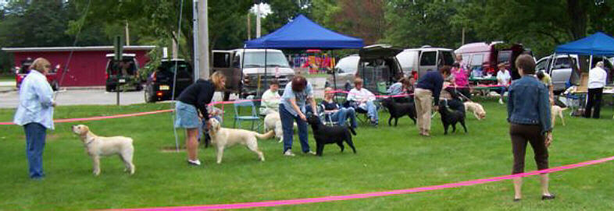

Long-haired Labrador Retrievers
DDC Veterinary in Fairfield, Ohio is pleased to announce a new DNA test for coat-length among Labrador Retrievers.
Long-haired coat length is inherited as an autosomal recessive trait, therefore dogs that are carriers of the long-hair allele will appear
to be short haired but will likely pass on the long-hair allele 50% of the time.
The purpose of this new DNA test is to accurately identify coat length genotypes. Breeders can use this information to manage mating patterns and make better selection decisions.
There are 3 genotypes for coat length can be identified with this new DNA test:
1) N/N Clear (those having 2 copies of the short-hair allele [N] and appear to be short-haired)
2) N/F Carrier (those having 1 copy of the normal short-hair allele [N] and 1 copy of the long-hair allele [F] and appear to be shorthaired)
3) F/F Affected (those having 2 copies of the long-hair allele [F] and appear to be long-haired)
Some of the particulars:
DNA samples can be collected easily at home using buccal (cheek) swabs provided as part of a free DNA sample collection kit.
Dogs can be DNA tested at ANY age.
The cost for testing is $58 (US) per canine with a $10 discount per test for 5 or more submitted at the same time. Payment can be submitted with the return samples.
A detailed DNA report will be mailed within 10 business days of receipt of the samples. Results are also emailed the day of completion to avoid potential delays with regular mail service.

For questions, comments, or to order sample collection kits, please call us at 1-800-625-0874 or email us at contact@vetdnacenter.com
You can also order sample collection kits online here: http://www.vetdnacenter.com/canine-long-hair-test.html
Thank you for your consideration.
DDC Veterinary
DNA Technology Park
One DDC Way
Fairfield, Ohio 45014
1-800-625-0874
www.vetdnacenter.com
About DDC:
DNA Diagnostics Center (DDC) in Fairfield, Ohio is the largest, most trusted private DNA testing laboratory in the world. DDC's highly
developed testing methods using PCR and state-of-the-art genetic analyzers have become the industry's standard for accurate, legally
defensible human DNA testing.
DDC's efforts to provide quality DNA testing services are also nationally and internationally recognized through a number of accreditations. DDC has achieved perfect ratings in its past 7
consecutive inspections, including those by the American Association of Blood Banks (AABB) and the College of American Pathologists (CAP).
DDC is also accredited by the National Forensic Science Technology Center to meet the standards of ISO 17025 and the DNA Advisory Board
(DAB).


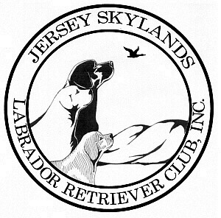
Jersey Skylands Labrador
Retriever Club Newsletter

Leslie Plank
Editor/Publisher
15 Thrush Drive
Smithtown, NY 11787

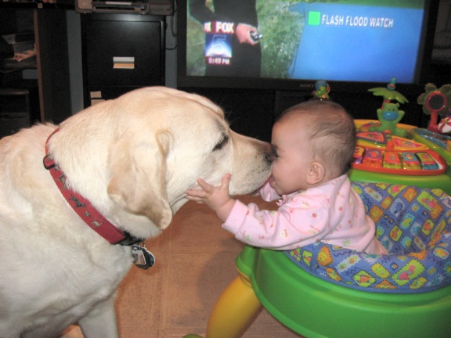

JSLRC Upcoming Events

Oct. 31, 2007 Board meeting: 7:30
Agenda: Assignment of committee chairs

Nov. 28, 2007 Board meeting: 7:30
General meeting: 8:00
Agenda: Annual Holiday Party

