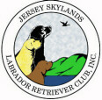 Skywriter 
Volume 2008, Issue 1 January/February 2008

Babes in Skyland
BREEDER REFERRAL LISTINGS
www.jerseyskylandslrc.com/BreederReferral.htm


BABES ALREADY LANDED

6 YEAR OLD NEUTERED BLACK MALE
Retired Canadian Champion. Very loving, great companion dog. Good with older children. Would like to be the only dog for someone to love. Great for semi-retired person. OFA Hips Good, OFA Elbows Normal, Eyes Optigen A. Current on shots.
Eve Ragalia 845-883-9143
windwoodkennels@aol.com

3 YEAR OLD BLACK FEMALE
Raised in breeder's home with children
She has a great, low key temperament - very, very quiet. Up to date on shots; Microchipped; Crate trained; Invisible Fence Trained
OFA Hips Good and Elbows Normal, Heart Cardiac Clear, Eyes CERF/ACVO Clear
Sire: Ch. Stonecrest's Davy Crockett
OFA Hips Good & Elbows Normal, CERF
Dam: Snugharbor Lady Pirate
OFA Hips Good & Elbows Normal, Eyes CERF
Gerri Kennedy-Youngblood 203-746-9432
snugharborlabs@sbcglobal.net

CHOCOLATE FEMALE PUPPIES
Born: November 07, 2007
Sire: Ch. Wingmaster Lobuff Aquarius Yogi
OFA Hips Fair, ACVO 12/04,Optigen Normal
Dam: Blackwatch Vanessa
OFA Hips Excel/Elbows Normal, ACVO 09/06, Optigen Normal
Karen Lolli 845-283-5725 or weekends (845) 783-3219

BLACK FEMALE PUPPY
Born: December 10, 2007
Sire: Ch. Woodhull's Roger That
OFA Hips Good/Elbows Normal, CERF 12/07 Optigen Normal
Dam: Blackwatch Breagh
OFA Hips/Elbows Normal, ACVO 09/06,Optigen Normal
Karen Lolli 845-783-3219 prefer evenings & weekends

BLACK MALE and FEMALE PUPPIES
Born: January 22, 2008
Sire: BISS Am.Can.Ch. Beechcroft's Study In Black
OFA Hips Good/Elbows Normal/Heart Echo Normal,
CERF 11/07 Optigen Normal
Dam: Folklaur Once Upon A Rhyme
OFA Hips Good/Elbows Normal/Heart Echo Normal,
CERF 02/07 Optigen Normal
Laura Dedering 610-599-7767 folklaur@epix.net
The breeders listed in our referral service are members in good standing of JSLRC, but under NO circumstance does JSLRC guarantee the services of said members. The buyer should review all contracts direc+tly with the breeder.
Full members, eligible for additional benefits, wishing to list a litter in the club newsletter and on the website must do so in writing ON THE CLUB FORM. Please send info to: Laura Dedering - JSLRC Breeder Referrals by email: jslrcinc@epix.net by mail: 98 Ramblewood Dr. Bangor, PA 18013-5601

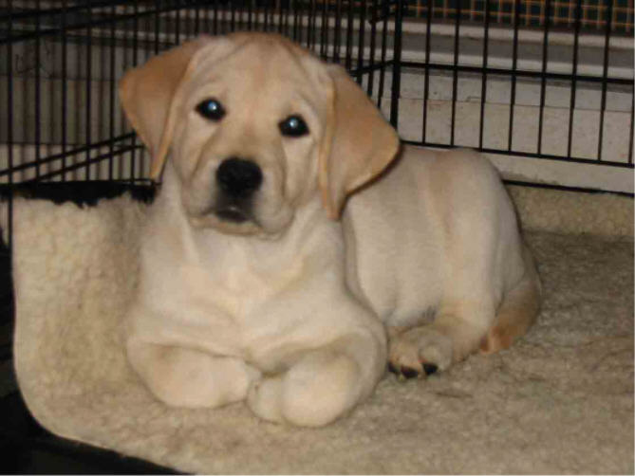

Table Of Contents

President’s Message Page 2
Assembly Bill 1591 Page 3
New Parvovirus Page 4
Pet Underpopulation Page 5
2008 Trophy Donations Page 9
Meeting Program Pics Page 10
April Health Clinic Flyer Page 11

JSLRC Officers and Board:

President: Sharon Celentano

Vice Pres: Karen Lolli

Secretary: Donna Sevchuk
190 Asbury Anderson Rd
Asbury, NJ 08802
(908) 537-7041

Treasurer: Laura Dedering

Directors:
1 Year - Ann DeGraw 2007-2008
2 Year - Laura Muirhead 2007-2009
2 Year - Donna Forte 2007-2009

Newsletter Staff:
Newsletter Editor and Publisher:

Leslie Plank
Smithtown, NY
631-724-7593
forestwood@dellmail.com

Contributing Editors
and Publishers:

Gerri Kennedy-Youngblood
New Fairfield, CT
203-746-9432
Snugharbor@gowebway.com

Lisa Grasso
Merrick, NY
516-456-9400
lisag22@optonline.net

Laura Dedering
Bangor, PA
610-599-7767
LauraDedering@epix.net

SKYWRITER is a publication of the Jersey Skylands Labrador Retriever Club, Inc. published six times a year with deadlines on the 15th of Feb, Apr, Jun, Aug, Oct and Dec. Contributions in the form of articles, news comments, wins, litter, and other items of interest to the membership are encouraged. Opinions expressed are those of the individual authors and not those of the JSLRC either in whole or in part. The Editor reserves the right to edit materials in the interest of space, literary clarity, good taste or timeliness. All deadlines will be strictly enforced. Subscriptions are available to non-members for $12.00 per year from JSLRC, through the Publisher.

By Eleanor Palmieri

No new members to report this month.

~
Committee Chairs are reminded to contact new members and get them involved in JSLRC activities.

Anyone interested in becoming a member of JSLRC can contact our Membership Chair for procedures and a membership packet.
Call or write to
Eleanor Palmieri -
JSLRC Membership Chair

252-728-0755
EPALMIERI@ec.rr.com



Only 7 more weeks until
Potomac!

PRESIDENT’S MESSAGE

Old Man Winter really seems to be flip-flopping around this year. Last week temperatures were in the low 30’s and we had snow and ice. A week later, the temperature reached sixty degrees. This was a sure sign that it really was time to take my Christmas tree down.

On January 26th, JSLRC sponsored the annual educational booth at the Lehigh Valley Canine Learning Experience. A big THANK YOU goes to Chair Sherri Mattheis for all of her talent, hard work and expertise in making this a great presentation and representing our wonderful breed. To set this booth up requires a lot of hard work and it is greatly appreciated. Thanks also go to Maryann Czerwinski, Donna Forte, Cathy Murch and Donna Sevchuk for helping on this event.

At the January 30th General Meeting, there was a Pizza Party and a program was given on “Evaluating Puppies”. Laura Dedering presented this very educational program. Hand-outs were made by Maryann Czerwinski, who also helped during the program with additional commentary. There were several litters of puppies there of different ages and Laura did an excellent job discussing structure. Over forty people attended, including many members from other area clubs. I have received emails from many people that attended, expressing how enjoyable this meeting was and how worthwhile the program was. THANK YOU Laura Dedering and Maryann Czerwinski. I would also like to express my thanks to Karen Lolli, Donna Forte, and Kathy Mines for allowing their puppies to be evaluated. In addition, thanks to Eve Ragalia for arranging and setting up the Pizza Party.

The winter Health Clinic was held on February 3rd. Many thanks and gratitude go out to Chair Donna Forte and Co-chair Phil Hess for the amazing job they did running the Health Clinic. This clinic was JSLRC’s most successful clinic to date. The clinic made a profit of $1400.00 for JSLRC. Thank you also to the many JSLRC members who came to help.

Our next General meeting will be held on May 28th. I hope to see you all there.

Sharon



Stars of the Sky

Cole Pop’s Thyme Is On My Side
Coastal SCLRC – 1st BBE
Coastal SCLRC – RWD
LRC of The Piedmont (1) – RWD
LRC of The Piedmont (2) – 2nd BBE
Owners: Becky Poppiti and Karen Day

Cole Pop’s Perfect Thyming
Coastal SCLRC – 3st Ambred
Coastal SCLRC – 2nd Ambred
LRC of The Piedmont (1) – 1st Ambred
LRC of The Piedmont (2) – 2nd Ambred
Owners: Becky Poppiti and Karen Day

Cedar Creeks All That Jazz
Delaware Water Gap KC – WB/BOW/BOS
3 point major!
Breeder/Owner/Handler: Sherri Mattheis

Am/Can. Ch. Wilcare Rockycreek Kahlua , JH, CD
LRC of The Piedmont (1) –1st Brood Bitch
LRC of The Piedmont (2) - 2nd Brood Bitch
Owners: Gerie and Kathy Mines

Rockycreek’s Snapdragon
LRC of The Piedmont (1) – 2nd 9-12 BB
4th 9-12 sweeps
LRC of The Piedmont (2) – 4th 9-12 BB
4th 9-12 sweeps
Breeder/Owners: Janice and Kathy Mines

Forestwood’s Unbelievable
Elm City KC – 1st Ambred / RWB
Breeder/Owner/Handler – Leslie Plank

Canine Learning Experience
Submitted by Sherri Mattheis, Chair

We had a wonderful day with lots of visitors to our booth this year. Thank you Maryann Czerwinski, Donna Forte, Cathy Murch, Donna Sevchuk and all of our 4-legged friends for being on hand to answer questions and to show the visitors wonderful examples of our breed!
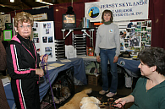

Assembly Bill 1591
AKC Alert - Assemblyman Neil Cohen and Assemblywoman Joan Voss have
introduced Assembly Bill 1591, a bill which threatens the rights of responsible breeders in New Jersey. This bill is a reintroduction of
2006's AB 3401. Fanciers, concerned dog owners, and responsible breeders
should immediately contact their representatives in the New Jersey State Legislature, and the members of the Assembly Agriculture and Natural
Resources Committee who will first hear this bill, and express their
vehement opposition to this bill.

The bill defines a "breeder" as any person who sells or offers to sell more than five puppies per year. In addition to this incredibly low threshold, the bill requires breeders to comply with a host of restrictive regulations and institutes steep fines for violations.

AB 1591 also prohibits any breeder from selling more than 25 dogs in one year.

The American Kennel Club vehemently opposes AB 1591's attempt to effectively outlaw breeding in New Jersey. Responsible breeders give the individual care and human contact that each puppy needs in order to grow into a healthy, well-adjusted ompanion and neighbor. Forcing responsible breeders out of business would deprive citizens of a most valuable resource when purchasing a pet.

The American Kennel Club believes that breeding programs should be undertaken responsibly for the purpose of preserving breed characteristics and producing healthy, well-socialized puppies. Responsible breeders are expected to give careful consideration to health issues, temperament, and genetic screening, as well as to the individual care and placement of puppies in responsible homes. AKC supports and promotes these and other responsible breeding practices through breeders' education programs, and commends those who offer similar guidance.

The American Kennel Club opposes the concept of breeding permits, breeding bans, or the mandatory spay/neuter of purebred dogs. Instead, we support reasonable and enforceable laws that protect the welfare and health of purebred dogs and do not restrict the rights of breeders and owners who take their responsibilities seriously.

AB 1591 goes far beyond encouraging responsible breeding. Under AB 1591, all breeders would be required to comply with draconian regulations including maintaining specified temperatures, keeping animals only on nonporous surfaces, and circulating air at precise levels. The measure further mandates the acceptable dimensions for crates and runs, and sets minimum socialization standards. Finally, all breeders are required to register annually with the Department of Health. This list will be published and made available to the public.

All breeders are required to furnish specified information to pet purchasers and provide a full refund for any reason for a pet returned within 14 days. Any dog which is sold with a pedigree can be returned for a full refund within 26 months if any congenital or genetic defects are discovered.

Violations can be punished with monetary fines or suspension of the license to sell pets. A first violation can result in a prohibition on selling cats or dogs for five years and subsequent offenses can add an additional five years for each violation.

Civil penalties may also be administered. For a first offense, a breeder shall be fined $5,000 and for a second offense the breeder may be fined $10,000 for each subsequent offense. A member of the public who supplies information that results in fines or suspension will be eligible for an award of 10 percent of the civil penalty or $250, whichever is greater.

WHAT YOU CAN DO:

Here is the link to email your legislator, ask them to please REJECT Assembly Bill 1591
http://www.njleg.state.nj.us/members/abcroster.asp

Contact the members of the NJ Assembly Agriculture and Natural Resources Committee. Urge them to oppose AB 1591.
Assemblyman Douglas H. Fisher, Chair
14 East Commerce St.
3rd Floor
Bridgeton, NJ 08302
(856) 455-1011

Assemblyman Nelson Albano, Vice-Chair
21 North Main St.
Cape May Court House, NH 08210
(609) 465-0700

Assemblyman John F. Amodeo

Assemblyman Herb Conaway, Jr.
Delran Professional Center
Suite 125
8008 Route 130 North
Delran, NJ 08075
(856) 461-3997

Assemblywoman Marcia A. Karrow
1 Maple Avenue
Flemington, NJ 08822
(908) 782-5127

Contact your own state Assemblyperson and Senator. Express your opposition to AB 1591, and urge them to do the same. To find out who represents you in the New Jersey State Assembly and State Senate, go to:
http://www.njleg.state.nj.us/districts/municipalities.asp.

For more information, please contact the AKC Canine Legislation Department at (919) 816-3720, or e-mail doglaw@akc.org; or contact the New Jersey
Federation of Dog Clubs at taborgsp@verison.net.

OSU Laboratory First to Discover a Virus in United States - OADDL Identifies A New Canine Parvovirus

http://www.cvhs.okstate.edu/index.php?option=com_content&task=view&id=437&Itemid=291

STILLWATER, Okla.—a team of Oklahoma State University (OSU) veterinarians, virologists and pathologists at the Oklahoma Animal Disease Diagnostic Laboratory (OADDL) recently published a paper in the Journal of Clinical Microbiology on their findings from a Canine parvovirus (CPV) study. Led by Dr. Sanjay Kapil, the group is the first to describe the CPV type 2c variant in the United States.

“We were quite fortunate to discover this variant,” explains Kapil. “It has been known for six years in Italy but nobody paid attention to it here until we found it last year.”

Shortly after Kapil joined the OSU Center for Veterinary Health Sciences, he received a case at the OADDL. The adult dog had been vaccinated multiple times and still became sick with Parvovirus.

“This was very unusual and we were totally surprised that it was CPV type 2c, which had not been found in the U.S. until then,” says Kapil. “What was so interesting was that after we described this disease, we ended up with samples from other locations here in the U.S.”

A patent has been filed on the characteristics of the U.S. CPV-2c. The team reports that 500 samples were submitted from locations in south California to south Florida. The published paper has been presented at national level meetings and internationally in Italy and Melbourne, Australia. However, their work is not done.

“The team work was most important. Sometimes we received ten dead puppies a day. We are working with several veterinarians and are receiving samples from cases with a history of vaccine failure,” continues Kapil. “Diagnostic laboratories need to be involved to identify CPV-2c. The disease now exists in all countries except Australia because of its geographical isolation.”

According to Kapil, the disease presentation is different in that normally parvovirus does not affect adult dogs only puppies. However, since publishing their findings, the OADDL has received samples from adult dogs in Minnesota.

“Veterinarians are confused because the in office diagnostic tests come up negative,” explains Kapil. “Clinically it looks like parvovirus so they send it to us. The OADDL tests it and it is parvovirus. Now world-wide (except for Australia), this particular variant can attack the heart and intestines.” He goes on to say that the mortality can be quite heavy. One breeder claims to have lost 600 puppies in one night. Without diagnostic confirmation, it is not known if the cause was simply this virus or if other factors were involved.

“We will continue to study CPV-2c. Through collaborations with others we will search for more effective vaccines,” he promises.

Of 80 cases tested by the OADDL, 26 were from Oklahoma puppies/dogs. Of those 26, 15 tested positive for CPV-2c. For more information on the Oklahoma State University Center for Veterinary Health Sciences, visit http://www.cvhs.okstate.edu.

Diamond Pet Food agrees to $3.1 million settlement with owners

The Associated Press
updated 12:28 p.m. ET, Fri., Jan. 4, 2008

COLUMBIA, S.C. - A company that made contaminated pet food that killed dozens of dogs nationwide will pay $3.1 million in a settlement with pet owners, an attorney said Friday.

The pet food, which contained a mold called aflatoxin, was produced at Diamond Pet Foods’ plant in South Carolina. The company will set up a fund to reimburse pet owners for the loss of their dog, veterinarian bills and the cost of any unreturned contaminated food, said attorney Jim Andrews, who represented a Knoxville, Tenn., family that sued the company.
Diamond Pet Foods, based in Meta, Mo., acknowledged that workers at its Gaston, S.C., plant failed to follow internal testing procedures to ensure its products were safe. The company made the acknowledgment after the Food and Drug Administration released a report showing the company has no record of test results for 12 shipments of corn in 2005, when grain tainted with the deadly fungus slipped into the plant.

The company contends it did nothing illegal, according to the settlement. Mark Schell, Diamond’s assistant general manager, did not immediately return a telephone message.
Aflatoxin, a naturally occurring chemical that comes from a fungus sometimes found on corn and in other crops, can cause severe liver damage.

The contaminated pet food was sold in 23 states. Diamond recalled about 20 varieties of dog and cat food when a New York veterinarian said in December 2005 that she had linked a dog’s death to the company’s food. An estimated 350,000 bags of dog food were recalled, according to the settlement.

For the rest of this article, please go to:

http://www.msnbc.msn.com/id/22505068/

Editor’s Note: The following article was reprinted with permission from the Spaniel Journal:

http://spanieljournal.com/33lbaughan.html

It gives some food for thought in response to the animal rights activist claims that there is a pet overpopulation.

Pet Underpopulation: The Pet Shortage in the US

by Loretta Baughan

Last month, I had the opportunity to be a guest on a talk radio program discussing recent pet legislation efforts in Wisconsin spearheaded by a small group of animal rights extremists. Some callers to the program realized the threat to pet owners and breeders such legislation poses and expressed concern. Many callers, however, were frantic about the "pet overpopulation" problem and thought laws were needed to stop breeders.
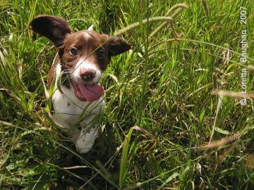

Listen up! The notion that there is a "pet overpopulation" problem is nothing more than a figment of the imagination of the anti-pet, anti-pet owner, anti-pet breeder animal rights fanatics.
Yes, you read that correctly. There is definitely NOT an overpopulation of dogs or cats, at least not in the United States. There may have been a problem 25-30 years ago, but due to heavy promotion of spay and neuter, it is estimated that over 75% of dogs and more than 87% of cats have been surgically sterilized (1). The pendulum has swung so far in the opposite direction that now, we are actually facing a shortage of pets... a pet underpopulation.

"In truth, there is no pet overpopulation problem. The Tufts Center for Animals and Public Policy has collected data about pet population that are striking:

Changes in Animal Population | 1973 | 1982 | 1990
US total dogs & cats (millions) | 65 | 91 | 110
dogs & cats euthanized (millions) | 13 | 10 | 5
% of animals euthanized | 20% | 11% | 4.5%"
- Animalscam: The Beastly Abuse of Human Rights by Kathleen Marquardt, Herbert M. Levine, Mark LaRochelle, published in 1993

Many in the animal rights crowd know this dirty little secret, but are unwilling to be honest about it since they would loose credibility - not to mention a very effective "tool" to leverage the public for donations, influence politicians to pass unnecessary legislation and the media to propagate their lies. Animal rights extremists have advanced their agenda by erroneously placing the blame for "pet overpopulation" on pet breeders. They have been successful at using this falsehood to convince pet owners that the "responsible" thing to do is to subject their pets to surgical sterilization in order to combat "pet overpopulation". Sadly, they have even hoodwinked many purebred breeders into thinking they must pressure their buyers to spay or neuter their puppies and kittens - to the detriment of many purebred gene pools. As a result, with fewer individual dogs being used in breeding programs, health problems are increasing as diversity is decreasing.

What are the facts?

According to the American Pet Products Manufacturers Association’s (APPMA) 2007-2008 National Pet Owners Survey (1), 63% of U.S. households own pets - up from 56% in 1988, which was the first year this study was conducted. With national population figures having increased from approximately 244,500,000 people in 1988 to 303,200,000 at the end of 2007 (2), the number of pet homes is ever increasing and at a greater rate than the human population. This is a trend that shows no sign of slowing down. The latest APPMA figures show that Americans own 74.8 million dogs and a whopping 88.3 million cats. We are a nation that loves pets and consider them part of the family. We open our hearts, our homes and our wallets to care for our pets. We spend a lot of money on our pets. In less than 20 years, this figure has nearly doubled - from $23 billion in 1988 to a projected $40.8 billion last year.
A shortage of homes for pets is not the problem. So, then, why are there so many dogs and cats in animal shelters?

In a nutshell, the answer to that question is poor management of shelters coupled with a resistance to adopt methods that work. Many of the smaller shelters are operated by people who love animals and desperately want to help, but are lacking in animal husbandry experience and management skills.

One shelter manager I spoke with blamed breeders for the dogs coming through their doors, then in an emotional rant, claimed that breeders are forcing their females to have three or four litters a year - keeping them pregnant all of the time. I interrupted her and said that was physically impossible since dogs typically only come into season twice a year. She then admitted she didn‘t know that and said, "Well, I’m not a breeder, myself."

The woman’s heart is in the right place, but without an understanding gained from hands on experience raising dogs or cats, how can we expect our shelters to succeed? Like it or not, an animal shelter is a business - and it has to be operated as such.

"Shelters and pounds reported to HSUS that by the 1980s, the number of animals they handled had decreased dramatically (Rowan and Williams 1997, 110-111). In addition, the animals handled by pounds and shelters seem to have changed demographically from unwanted litters to young, untrained dogs and cats (Patronek 1996, 1)." -- Bridging the Bond: The Cultural Construction of the Shelter Pet by Tami L. Harbolt

Most of the dogs entering shelters are surrendered by their owners due to behavior issues. Often, it boils down to a simple lack of training. Animal shelters that offer obedience classes can help curb the influx of this type of dog into their shelter - while doing the dog, the owner and the community a service.

Other dogs are brought to shelters because they are sick or old and their owners cannot afford to pay - or do not want to pay - for vet care or euthanasia.

In some shelters, cats may out number dogs by about a two-to-one ratio. Many of these cats are feral and are owned by no one. Most are classified as "unadoptable" - yet they are included in the shelter statistics. Programs that catch feral cats, sterilize them and release them are demonstrating success in reducing their numbers.
Animal shelters are importing dogs by the thousands!

Meanwhile, well run animal shelters have become victims of their own success. In order to keep their doors open and justify new million-dollar facilities and salaries, some animal shelters have found a "new" source of dogs... and have been importing them by the thousands.

Here, in Wisconsin, animal shelters in Green Bay and Milwaukee have a pet underpopulation problem and have been importing thousands of puppies into the state for the past several years. Through the PetSmart Charities Rescue Waggin’, they have brought in puppies from Iowa, Indiana, Illinois, Tennessee and Kentucky - as many as 50 at a time. The Green Bay Press-Gazette reported in December that the 32 dogs arriving Thursday evening (Dec 6, 2007) were expected to be "adopted out by this weekend" (3).

H.O.P.E. Safehouse, out of Racine, is more of a rescue organization than an animal shelter as they do not have a facility of their own, but rely on volunteers to care for the dogs they import, mainly from the south. A Milwaukee Public Radio online news article reports that this group recently brought in a shipment of 100 puppies from Kentucky, many of which were sick. The same article (Jan 11, 2008) goes on to say that the Wisconsin Humane Society in Milwaukee has imported 9,000 dogs with more animals arriving there via the Rescue Waggin' "a few times a week" - and that they have "hundreds of families looking for animals to adopt". (4)

Other shelters within our state have available dogs, so rather than bring in animals from other states, why not first assist the smaller Wisconsin shelters by placing their surplus dogs? Could it be that by emptying shelters around the state, it would be difficult - if not impossible - to continue the illusion that a "pet overpopulation" problem exists?

This PetSmart program is not exclusive to Wisconsin. Shelters in many other areas of the country are participating. The Rescue Waggin’ transports puppies from shelters struggling to find homes to areas where the demand for dogs is higher than the supply. That’s a win-win situation for all, especially the dogs. However, to continue the charade of claiming a "pet overpopulation" problem exists is dishonest. Another concern is that the thousands of animals being transferred from one shelter to another are being tallied twice, creating an impression that there are far more homeless pets then actually exist.

"Animal shelters in the USA are casting a wide net - from Puerto Rico to as far as Taiwan - to fill kennels. Critics say many shelters have solved the stray problem in their own area - but rather than shut down, they become de facto pet stores. Some charge more than $200 per adoption for imported dogs," reports USA Today (5). More than 14,000 strays have been shipped in from Puerto Rico, and many thousands more are being imported from Mexico, India and the Bahamas each year. Another USA Today article warns, "Agencies in Southern California created the Border Puppy Task Force after they saw a surprising number of very young dogs being brought across the border from Mexico. The task force estimated that during a one-year span, 10,000 puppies entered San Diego County." (6)

There are legitimate concerns that animal shelters importing stray dogs from foreign countries may be importing disease, as well. Besides health issues, these street dogs lack proper socialization and may have poor temperaments. Is it ethical for animal shelters to expose the public to these unknowns, while condemning anyone who breeds a litter in our country? I don’t think so.

The National Council on Pet Population Study and Policy (NCPPSP) was formed in the early 1990s. Member groups include the American Humane Association (AHA), the American Pet Products Manufacturers Association (APPMA), American Veterinary Medical Association (AVMA), Cat Fanciers Association (CFA), the Humane Society of the United States (HSUS) and others. Between 1994-1997 they sent questionnaires to animal shelters around the country seeking to compile statistics for the numbers of intake animals, animals reclaimed by owners, those who found new homes and euthanasia. But due to a low number of shelters willing to respond, the study was discontinued a decade ago.

Without insisting on reliable statistics and factual evidence to back up their claims, we have allowed the fox to patrol the hen house. We can no longer blindly accept the pie-in-the-sky guesstimates groups such as the Humane Society of the United States (HSUS), People for the Ethical Treatment of Animals (PETA) and other similar agenda-driven animal extremists put forth. Follow the money. These are organizations whose very existence are dependant upon the amount of money they can raise from misguided animal lovers who think their donation is actually helping puppies, kittens or their local animal shelter. The reality is that these animal rights fanatics seek to impose their vegan lifestyle and utopian dream for humans to have zero contact with animals.

"But as the surplus of cats and dogs (artificially engineered by centuries of forced breeding) declined, eventually companion animals would be phased out, and we would return to a more symbiotic relationship enjoyment at a distance." -- Ingrid Newkirk, PETA co-founder and president, quoted in The Harper's Forum Book, Jack Hitt, ed., 1989, p.223.

Is that the kind of future the majority of U.S. citizens envision? I don’t think so. The lunatic animal rights movement does not represent mainstream American views or values.

So how do we solve the problem?

"The key is to get raw data. How many animals are coming in and how many are going home alive? And, is that improving every single year? Because, if it is not, there is a serious problem with leadership and the mechanisms going on within that shelter." -- Nathan J. Winograd, director of the national No Kill Advocacy Center, former director of operations San Francisco SPCA, executive director of the Tompkins County SPCA and author of Redemption: The Myth of Pet Overpopulation and the No Kill Revolution in America (7), interview with Animal Wise Radio, aired Feb 4, 2007

Mr. Winograd is spot on. A handful of states are waking up to this realization and are requiring animal shelter accountability - through record keeping and the reporting of statistics. Virginia is one such state. Since People for the Ethical Treatment of Animals’ (PETA) headquarters is located within that state, they are required by law to file:

"Not counting animals PETA held only temporarily in its spay-neuter program, the organization took in 3,061 "companion animals" in 2006, of which it killed 2,981 (8). According to Virginia’s Department of Agriculture and Consumer Services (VDACS), the average euthanasia rate for humane societies in the state was just 34.7 percent in 2006. PETA killed 97.4 percent of the animals it took in. The organization filed its 2006 report this month, nine months after the VDACS deadline of March 31, 2007 (9)," reveals The Center for Consumer Freedom.

In other states where shelters are required to report their statistics, euthanasia rates are alarming. Michigan reports approximately 45% of dogs and 75% of cats that enter their animal shelters are killed. Between 2001-2006 North Carolina shelters killed about 77% of their dogs and cats.

As dog owners, I think we are all deeply disturbed over the plight of animals in shelters and the high rate of euthanasia. There is a solution. Nathan Winograd has proven his "No Kill Revolution" method works - in both large and small shelters. As dog breeders and trainers, we are the experts, so it is up to us to step forward and assist our local shelters in overcoming their problems. The first step is to stop blaming pet breeders and lay to rest, once and for all, the myth of "pet overpopulation". It’s time to embrace the fact that we have a pet underpopulation situation... and so, the solution to our local animal shelter problems is within our grasp.

Sources:
(1) - 2007-2008 National Pet Owners Survey, American Pet Products Manufacturers Association Inc. (APPMA)
(2) - U.S. Census Bureau, U.S. POP Clock Projection and Historical National Population Estimates
(3) - Humane Society's Puppy Population Boom Expected to be Short-Lived: 32 dogs sent to shelter likely to be adopted quickly by Paul Srubas, Green Bay Press-Gazette, December 7, 2007
(4) - Interstate Efforts to Save Shelter Dogs by Ann-Elise Henzl, WUWM Milwaukee Public Radio news, January 11, 2008
(5) - More Cities Importing Pound Puppies by Tom Vanden Brook, USA Today
(6) - Dog Imports Raise Fears of a Resurgence of Disease by Alan Gomez, USA Today
(7) - Redemption: The Myth of Pet Overpopulation and the No Kill Revolution in America by Nathan J. Winograd, copies available through the Spaniel Journal Bookstore
(8) - Virginia Department of Agriculture and Consumer Services, People for the Ethical Treatment of Animals 2006 animal report
(9) - PETA Killed 97 Percent of "Companion Animals" in 2006: Death Toll Up To 17,400; Report Describes PETA’s Deadliest Year Ever, January 10, 2008 press release from The Center for Consumer Freedom, courtesy of David Martosko, CCF Director of Research

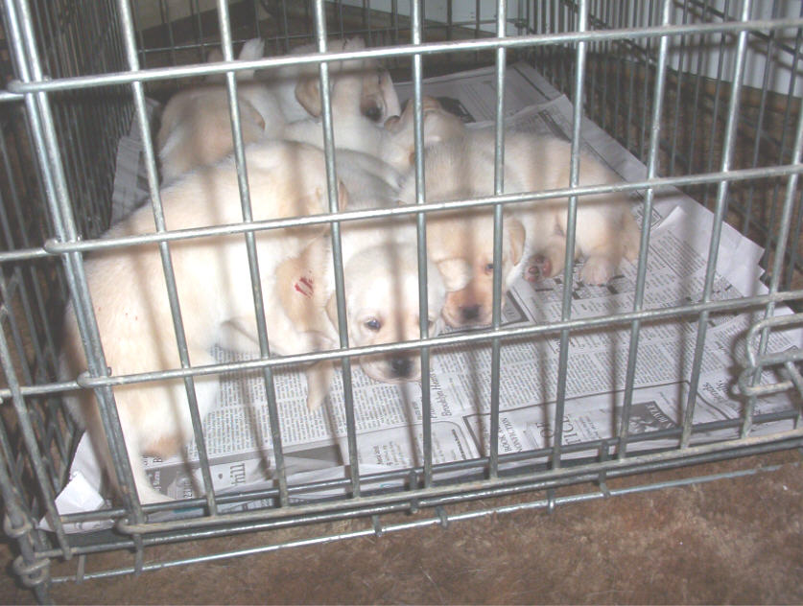

Hi ALL JSLRC Members,

We wish to extend a BIG THANK YOU to those who have already generously sponsored and paid for trophies.

We also wish to say Thank You to the others who have already pledged. We would appreciate if you would send in your payments now, since we have already started placing the orders and they need to be Paid In Advance.

There are several Classes that still need trophy sponsors.

We ask that all of our members please be generous and donate trophies for our club's shows. There is a $5.00 discount if you sponsor the same class for both days.

Contact our Trophy Chair - Ann DeGraw at 908-362-5514 ancroft@embarqmail.com to find out which classes are still available. If you do not have a particular class in mind, please send a donation to the General Trophy Fund.

Please send your donations made payable to: JSLRC, Inc.
and Mail to:
Laura Dedering - JSLRC Treasurer
98 Ramblewood Drive
Bangor, PA 18013-5601

Thank you,
The Point Show Committee


Meeting Program: Evaluating Puppies - Photos by Jeff Evans
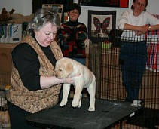 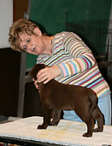
Presenters: Laura Dedering and Maryann Czerwinski
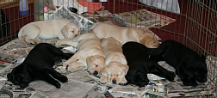 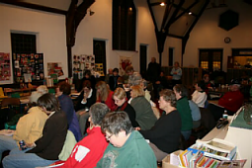
Donna Forte’s Puppies A large attendance
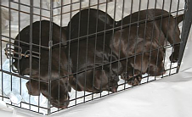 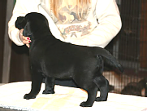
Karen Lolli’s Puppies Kathy Mines’ Puppies
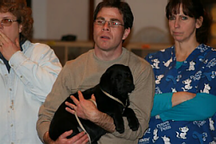 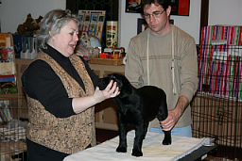
Tambra and Tom Flaherty’s puppy

Jersey Skylands Labrador Retriever Club, Inc.

ALL BREED CANINE HEALTH CLINIC

SUNDAY, APRIL 27, 2008, 10:00 AM to 1:00 PM

LOCATION: FLANNERY ANIMAL HOSPITAL PC, 789 Little Britain Rd., New Windsor (Newburgh), NY 12563 845-565-7387

DIRECTIONS: From East/West - Rt. 84 to Exit 7S (Rt. 300 South) Continue on Rt. 300 South to sixth light. Turn left on Rt.
300/207. Take left at first light. Flannery Animal Hospital is first driveway on right.

From North/South – NYS Thruway (Rt. 87) to Exit 17 (Newburgh.) Follow signs for Rt. 17K. Turn right onto Rt.
17K. At first light turn left on to Rt. 300 South to fourth light. Turn left on Rt. 300/207. Take left at first light.
Flannery Animal Hospital is first driveway on right.

EYE EXAMS: Marjorie Neaderland, DVM, ACVO Diplomate Purdue University. Dogs must be over 7 weeks of age.
CERF forms provided. Bring registration and permanent ID information. All results strictly CONFIDENTIAL.

HEART EXAMS: Josh Gidlewski, DVM, Diplomate DACIM Cardiologist. OFA forms will be provided. Please bring AKC
registration and permanent ID information. All results strictly CONFIDENTIAL. Pre-registration and payment is strongly recommended; lack of interest will result in cancellation of this service.

MICROCHIP: Home Again Microchip will permanently identify your dog. AKC now requires that all dogs be microchipped or
tattooed for OFA and CERF registration. Home Again registry form will be provided.

BLOOD TESTS: Results available within minutes and strictly CONFIDENTIAL - See Registration form for list of services.
Heartworm medication will be available for purchase from Flannery Animal Hospital with a negative heartworm test
result.

RABIES: Certificate will be provided on site. Bring proof of previous vaccination, if available.

REGISTER: Pre-Registration by 4/20/08. Fill out form and mail with appropriate fees as indicated. Appointments will be
scheduled on a first come-first served basis. Every effort will be made to schedule your appointments in the
time frame requested. WALK INS WILL BE SEEN AS TIME ALLOWS.

FMI: Contact Karen Lolli (845) 283-5725 for more information or to register by phone.
___________________________________________________________________________________________________________

PLEASE RETURN COMPLETED FORM BY 4/20/08 with your NON-REFUNDABLE CHECK MADE OUT TO JSLRC, INC.
MAIL TO: Karen Lolli, 82 Old Mansion Road, Chester, NY 10918

Name: Telephone _
Address:
City: State: Zip: email:
TIME SLOT PREFERRED, PLEASE NUMBER 1-3 IN ORDER OF PREFERENCE:
____10:00-11:00 ____11:00-12:00 ____12:00-1:00

SERVICES | UNIT COST X # OF DOGS | = EXTENDED AMOUNT
ACVO EYE EXAM | $25.00 X | = $
MICROCHIP | $28.00 X | = $
HEARTWORM/LYME/EHRLICHIA | $32.00 X | = $
AUSCULTATION | $40.00 X | = $
ECHOCARDIOGRAM | $210.00 X | = $
RABIES | $17.00 X | = $
 | TOTAL: | = $

I HEREBY RELEASE FLANNERY ANIMAL HOSPITAL PC., JSLRC,INC., ITS MEMBERS AND AGENTS FROM ANY AND ALL INJURIES OR LOSSES SUSTAINED BY MYSELF OR MY DOG(S) WHILE AT THIS HEALTH EVENT.

Please sign:

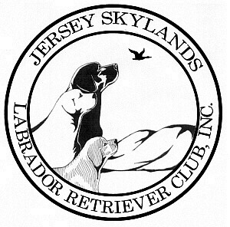
Jersey Skylands Labrador
Retriever Club Newsletter

Leslie Plank
Editor/Publisher
15 Thrush Drive
Smithtown, NY 11787

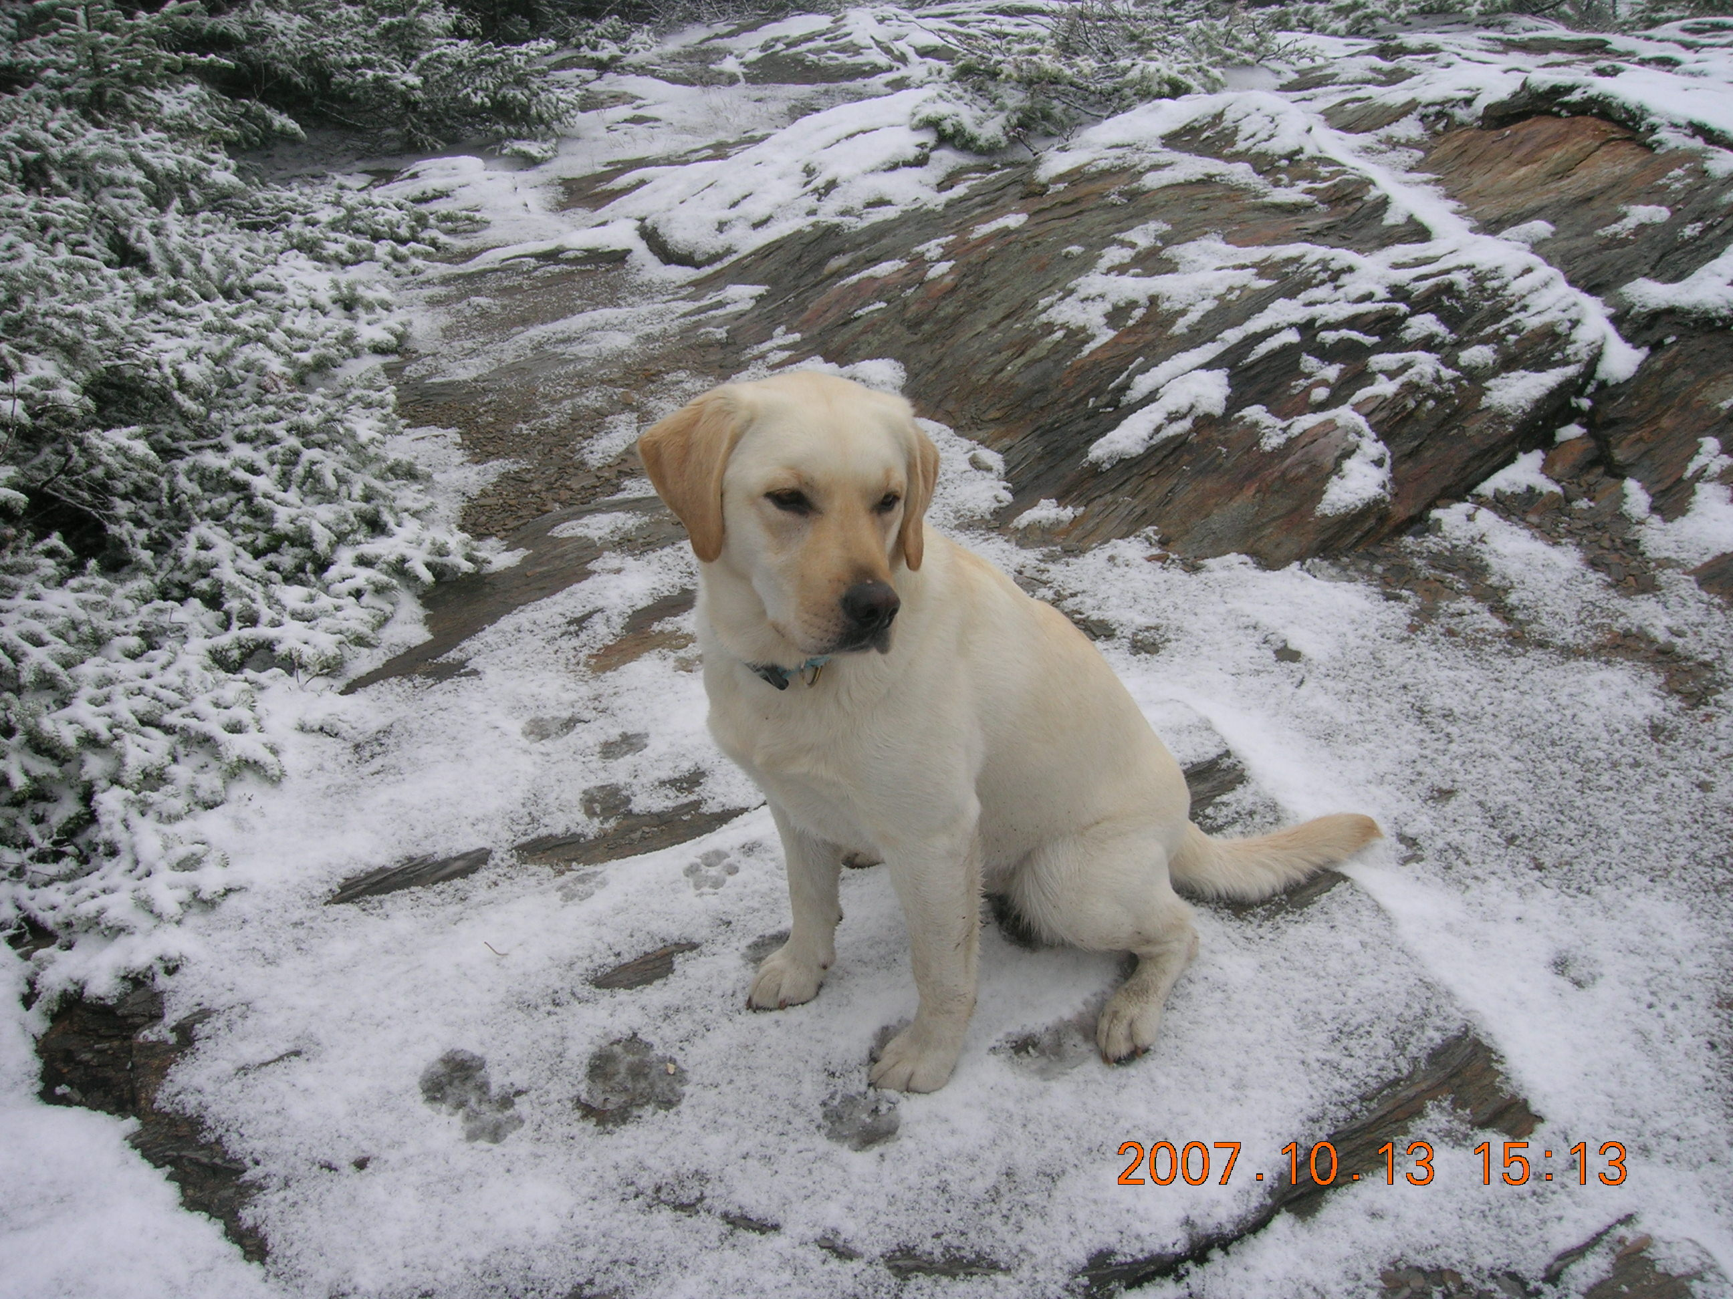

JSLRC Upcoming Events

Feb. 28, 2008 Board meeting: 7:30 PM
Agenda: TBA

March 26, 2008 Board meeting: 7:30 PM
Agenda: TBA

April 27, 2008 All Breed Health Clinic
Flannery Animal Hospital
FMI: Karen Lolli 845 283-5725

April 30, 2008 Board meeting: 7:30 PM
Agenda: Appoint nominating committee

