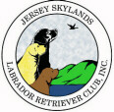 Skywriter 
Volume 2010, Issue 4 July/August 2010

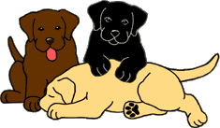
Babes in Skyland
BREEDER REFERRAL LISTINGS
www.jerseyskylandslrc.com/BreederReferral.htm

5 YEAR OLD BLACK FEMALE – SPAYED
Sugar is extremely sweet and obedient. She would like to be the only dog for someone to love and share their bed with. A place to swim her would be a Plus. Great for an active, retired couple. Up to date with shots.
OFA clearances and Optigen clear.
Sire: Am.Can.Ch. Beechcroft's Study In Black
Dam: Windwood's Mya
Breeder/owner must place some of her dogs due to her own medical problems.
Eve Ragalia 845-883-9143 windwoodkennels@aol.com

14 MONTH OLD BLACK MALE PUPPY - NEUTERED
Born: June 7, 2009
This boy loves people, is extremely gentle and gets along with other dogs. He has all of his shots, is crate and obedience trained.
Sire: Ch. Liberty Hill Luke Jr.
OFA Hips Good and Elbows Normal, CERF May 2009
Dam: Windwood's Midnight Lace
OFA Hips Good and Elbows Normal, CERF May 2009
Breeder/owner must place some of her dogs due to her own medical problems.
Eve Ragalia 845-883-9143 windwoodkennels@aol.com

11 MONTH OLD BLACK FEMALE PUPPY
Born: Sept 26, 2009
Sire: MBISS CH. Beechcroft Study’s Top Secret
OFA Hips Good/Elbows Normal, Heart Echo Normal, CERF Nov. 2009 and Optigen clear
Dam: Blackwatch Breagh
OFA Hips and Elbows; Heart Echo Normal, Eyes ACVO May 2009 and Optigen Clear
Karen Lolli 845-283-5725

BLACK MALE PUPPIES
Born: June 24, 2010
Sire: Ch. Kai Den's Power Surge RN TDI
OFA Hips Good, Elbows Normal, Heart Echo Normal; CERF Oct 2009 and Optigen Normal; EIC Normal
Dam: Ancroft Gentleman Prefer Blondes
OFA Good, Elbows Normal, ACVO Feb. 2010,Optg.NBP
Ann DeGraw 908-362-5514
ancroft@embarqmail.com
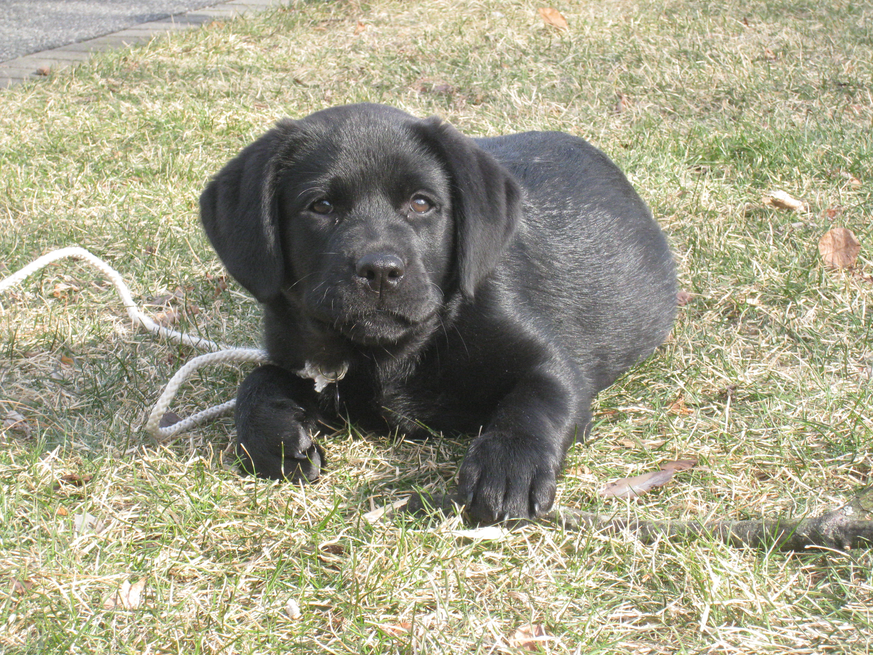
The breeders listed in our referral service are members in good standing of JSLRC, but under NO circumstance does JSLRC guarantee the services of said members. The buyer should review all contracts directly with the breeder.
Full members, eligible for additional benefits, wishing to list a litter in the club newsletter and on the website must do so in writing ON THE CLUB FORM.

Please send info ON THE CLUB FORM to:
Laura Dedering - JSLRC Breeder Referrals
by email: jslrcinc@epix.net
by Fax: 610-599-7723
by mail: 98 Ramblewood Dr.
Bangor, PA 18013-5601

2009 – 2010
JSLRC Officers and Board:

President: Donna Forte

Vice Pres: Sharon Celentano

Secretary: Donna Sevchuk
190 Asbury Anderson Rd
Asbury, NJ 08802
(908) 537-7041

Treasurer: Laura Dedering

Directors:
1 Year - Ann DeGraw 2009-2010
2 Year - Laura Muirhead 2009-2011
2 Year – Karen Lolli 2009-2011

Newsletter Staff:
Newsletter Editor and Publisher:

Leslie Plank
Smithtown, NY
631-724-7593
forestwood@dellmail.com

Contributing Editors
and Publishers:

Lisa Grasso
Merrick, NY
516-456-9400
lisag22@optonline.net

Laura Dedering
Bangor, PA
610-599-7767
LauraDedering@epix.net

SKYWRITER is a publication of the Jersey Skylands Labrador Retriever Club, Inc. published six times a year with deadlines on the 15th of Feb, Apr, Jun, Aug, Oct and Dec. Contributions in the form of articles, news comments, wins, litter, and other items of interest to the membership are encouraged. Opinions expressed are those of the individual authors and not those of the JSLRC either in whole or in part. The Editor reserves the right to edit materials in the interest of space, literary clarity, good taste or timeliness. All deadlines will be strictly enforced. Subscriptions are available to non-members for $12.00 per year from JSLRC, through the Publisher.


By Sherri Mattheis
New Member Applications
New members voted in at the 8/22/2010 meeting:
Tom and Marie Davidson
117 Bradford Street
Glen Rock, NJ
(201)621-8616
tomsamd@verizon.net

Malou Walther
52 Old York Road
New Hope, PA 18938
(215) 862-3069
malouw@verizon.net
~
Committee Chairs are reminded to contact new members and get them involved in JSLRC activities.

Anyone interested in becoming a member of JSLRC can contact our Membership Chair for procedures and a membership packet.

Call or write to
Sherri Mattheis -
JSLRC Membership Chair

908-689-5865
cedarmarsh@comcast.net

Table Of Contents

Labrador Lifeline Pg 4

Meeting Notices Pg 4

Obedience Report Pg 5

Labradoodles Pg 5

Match Show Results Pg 7

Dues Renewal Pg 10

PRESIDENT’S MESSAGE

Hello All,

I can’t believe how time is flying, every year seems to go quicker and quicker!

Our club calendar year starts again on Sept 1. Our first event of the year will be our Back to Back Specialties on September 3rd & 4^{th.} Please contact Maryann Czerwinski and offer your assistance. We have more than doubled our entry from last year, so there is plenty to do when it comes to the shows. I’m looking forward to seeing everyone there! We’re also looking for everyone to bring some finger food snack for the Friday hospitality table, which Donna Sevchuk is coordinating. Also, don’t forget your raffle item for Corey Anger, she always has such a great table put together for Saturday afternoon.

I wanted to make everyone aware that Dr. Dashfield will be at the Newton Shows during our Specialties and will be running a modified health clinic. She will be offering Optigen testing, EIC testing, blood tests through Dr Jean Dodds, as well as vaccinations, microchipping and the 4-way Snap test.

Once again Elisabeth Henry did a wonderful job with the August Match and Encore Match. While the weather didn’t cooperate, everyone had a good time and our judges, Kim Silva & Fabian Negron were fantastic, my thanks to them. Pictures and results are posted on the club website and in this issue.

Remember to fill out your dues form and get it into Sherri Mattheis.

Enjoy the rest of your summer, it’ll be winter before we blink!
Donna

Stars of the Sky 

Am/Can. Ch. Brookberry’s Perfect Impression
Twin Brooks KC Day 1 – BOB
Twin Brooks KC Day 2 – BOB
Bennington County KC – Select Dog (major)
In Canada:
Limestone KC Day 1– WD/BOW/BOB (5 pt Major)
Limestone KC Day 3 – WD/BOW/BOB/G1 (5 pt Major)
Eastern Ontario Labrador Breeders Assoc.Day 1 – 1st BBE
Limestone KC Day 4 – WD/BOW/BOB (5 pt Major)
New Canadian Champion!
Best BBE/BBE G1
Eastern Ontario Labrador Breeders Assoc.Day 2 – 1st BBE
Breeder/Owner/Handler: Donna and Stephanie Forte

Brookberry’s Perfect Addition
Limestone KC Day 2 – WB
Breeder/Owner/Handler: Donna and Stephanie Forte

Can. Ch. Brookberry’s American Dream
Twin Brooks KC Day 1 – WB
Twin Brooks KC Day 2 – WB
Breeder/Owner/Handler: Phil and Susan Hess and Stephanie Forte

Am/Can CH Cedar Creeks All That Jazz
Limestone City Kennel Club Day 1 WB
New Canadian Champion!
Breeder/Owner/Handler: Sherri and Tyler Mattheis

Cedarmarsh's Plantin' a Wish
Limestone City Kennel Club Day 1 RWB
Limestone City Kennel Club Day 3 RWB
Breeder/Owner/Handler: Sherri and Tyler Mattheis

Broadway's South Pacific
JSLRC Encore Match – 1st Open Dog & Best Adult In Match!
Owners: Maryann Czerwinski and Donna Sevchuk
Forestwood’s Rox Star Girl
Mid-Hudson Kennel Assoc.-
WB/BOW/BOB
Riverhead KC Day 1 – WB
Hunterdon Hills KC – WB/BOW/BOB
Also made cut in Sporting Group to final 5
Penn Treaty KC - RWB
Breeder/Owner: Leslie Plank

Forestwood’s Plum Crazy Purple
Staten Island KC – 1st 6-9 puppy, WB
Pawkatuck River LRC supported entry at Providence County KC –
1st 6-9 Puppy Bitch Sweeps
Breeder/Owner: Leslie Plank

Am.Can. Ch. Folklaur Storybook Ending
Susque-Nango KC - WB/BOS
Tioga KC - WB/BW/BOS
New AKC Champion!
Breeder/Owner: Laura Dedering

Can. Ch. Folklaur Neverending Story
Kanadasaga KC - WD/BOW
Naugatuck KC - WD
Farmington Valley KC - WD/BOW
Breeder/Owner: Laura Dedering

Can. Ch. Folklaur Abracadabra
In Canada-
Bluewater KC #2 - WB
Bluewater KC #3 - WB/BOW
Oxford KC #1 - WB
Woodstock KC #1 - WB/BOW
New Canadian Champion!
Breeder/Owner: Laura Dedering

Folklaur Secret Desire
JSLRC Match – 1st 12-18 Bitch
Best Adult In Match!
JSLRC Encore Match – 1st 12-18 Bitch
Breeder/Owner: Laura Dedering

Branwood’s Morning Mischief
Putnam KC Day 1 – WB/BOW/BOS
Putnam KC Day 2 - RWB
Breeder/Owner/Handler: Hallie Scherck
Snowcrest Sailing Wit Da Win At Ginspin
Wallkill KC – 1st 9-12 puppy
WD, BOW
Owner: Dottie Martin

Blackwatch Strawberry Fields Forever
JSLRC Encore Match – 1st Novice Bitch
BOS Adult In Match!
Breeder/Owner: Karen Lolli

Araby’s Joltin’ Joe DiMaggio RN
Bennington County KC – Qualified Rally
New Rally Novice Title!
Owners: Barbara Roosevelt and Mary Sgambati

Brookberry Wagging Wonder RA
Doberman Pinscher Club of the Tappan Zee - Qualified Rally Excellent, 1st Place
Lackawanna Kennel Club -
Qualified Rally Excellent, 4th Place
Owners: Fran Pidgeon & Bill Pidgeon

Startop's Blaze of Glory RE
Doberman Pinscher Club of the Tappan Zee -
Qualified Rally Advanced & Excellent (RAE)
Owners: Fran Pidgeon & Bill Pidgeon

Porter
JSLRC Morning Match- 1st 3-4 puppy dog
BOS Puppy In Match!
JSLRC Encore Match – 1st 3-4 puppy dog
BOS Puppy In Match!
Owners: Tamara, Mike & Payton Karabinus

Breeze
JSLRC Encore Match – 1st 3-4 puppy bitch
Best Puppy In Match!
Breeder/Owner: Kathy Mines



I’m Barbara Roosevelt of Araby Labradors and I volunteer for Labrador Life Line. I’m writing to all of the Lab clubs to ask for help raising money to support the Labradors we all love so much.

LLL will be holding our annual online auction at the end of September and we’re looking for donations of clothing decorated with Labs and/or club logos. When we polled our usual contributors, we discovered Lab related clothing was one of the items they valued most so we’re trying to increase the number of choices they have to bid on. If you could spare anything at all, we'd be very grateful!

Thanks in advance for any assistance you can give us!
Yours,
Barbara Roosevelt
Labrador Life Line

On January 1, 2006 AKC made a change in policy which permits clubs to send members notification of club meetings and board members notification of board meetings via email, provided the member has signed an authorization agreeing to this method of communication. This policy was presented at our May 26, 2010 General Meeting and a motion made to implement the email policy. Motion carried 23-0-1 absentia. For the members that were not in attendance please contact the club secretary as to how you would like to receive your notice.

Thank you,
Donna Sevchuk, Secretary



MEMBERSHIP DUES
Club Membership Dues for the 2010 - 2011 year are due. If you have not already sent in your membership dues along with your renewal form please do so.
Please Note: NEW members voted in AFTER April 1, 2010 are paid through August 31, 2011, and need not pay dues.
**See Dues Renewal Form in this newsletter.

OBEDIENCE COMMITTEE REPORT
Submitted by Fran Pidgeon
Obedience Chairperson

JSLRC, Inc. hosted the club’s second Rally Fun Day on Saturday, July 31, 2010. Thank you to Laura Dedering (Folklaur Labradors) for opening her home and property to the club once again for Rally Fun Day. The weather was perfect for a day of outdoor training with the dogs. Participants welcomed the sunny skies, lower temperatures, and lower humidity after the previous heat-waves.

Eight dog and handler teams attended the Rally Fun Day. Several teams attended the club’s first Rally Fun Day in May and it was wonderful to see their progress in both attention and performance on the Rally Novice course. For other teams, this was their first introduction to Rally and it was exciting to see how well both dogs and handlers navigated the Novice course for the first time.

Teamwork was evident between the dogs and handlers as they practiced the Rally exercises. Congratulations to all participants on their progress! Hopefully some club members will experience the thrill of earning a Rally Novice title in the near future. Keep up the great work and happy Rallying!

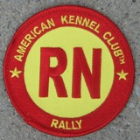

Labradoodle Pioneer Regrets Fashioning 'Designer Dog'
Published May 02, 2010
Edited from it’s original content
The man who bred the first labradoodle - and in the process made the mutt a desirable accessory - says it's the great regret of his life. The coveted accessory has pushed out other breeds in terms of desirability.

Wally Conran, 81, coined the term labradoodle in 1988, when he was the manager of the puppy program at the Royal Institute of the Blind. He received a letter from a woman in Hawaii who needed a seeing eye dog, but her husband had allergies. She wanted a dog that would not shed hair.

Mr Conran crossed two popular pedigree dogs: a Labrador from breeding stock at the institute and a poodle owned by his boss to create the labradoodle. The puppies were supposed to have the best traits of both dogs: the affable, controllable nature of the Labrador, and the curly, non-shedding coat of the poodle.

"But now when people ask me, `Did you breed the first one', I have to say, `Yes, I did, but it's not something I'm proud of'," Mr Conran said. "I wish I could turn the clock back."

The labradoodle is now recognized as the first of the so-called "designer dogs", selling for more than $1000 a puppy. In essence, it is a mutt, or mongrel, yet it has raced ahead of pedigrees in terms of price and desirability.
Some pet shops report mongrels outselling pure-breds three to one, despite the high price of both.
As a result, labradoodles and their cutely named cousins -- spoodles, schnoodles, cavoodles, moodles, groodles and roodles -- are being pumped out across the nation, to meet demand.

"I'm not at all proud of my involvement in it," Conran said. "But the genie's out of the bottle, and you can't put it back."
His dismay isn't shared by breeders of the curly cross-breeds, who say they are merely meeting demand for a family-oriented, non-shedding dog of compact size, and happy temperament………………….
The rise in popularity of the mutts angers pedigree breeders, who complain that cross-breeders are exploiting the fad for money, and forcing pedigree bitches to give birth to dozens of cross-bred pups every year.
To read the complete story go to:
http://www.foxnews.com/world/2010/05/02/labradoodle-pioneer-regrets-fashioning-designer-dog/?test=faces

From The Labrador Retriever Club, Inc:
The Labrador Retriever Club, Incorporated is dedicated to the health and welfare of the Labrador Retriever breed while conserving the original breed function - that of a "working retriever." A purebred dog offers to his owner the likelihood that he will be a specific size, shape, color and temperament. The predictability of a breed comes from selection for traits that are desirable and away from traits that are undesirable. When a breed standard or type is set, the animals within that breed have less heterozygosity than do animals in a random population
A Labradoodle is nothing more than an expensive crossbred. Because the genetic makeup is diverse from the Poodle genes and the Labrador genes, the resultant first generation (F1) offspring is a complete genetic gamble. The dog may be any size, color, coat texture and temperament. Indeed Labradoodles do shed. Their coat may be wiry or silky and may mat. Body shape varies with parentage but tends to be lanky and narrow. Behavior varies with the dog and within a litter with some puppies poodle-like in attitude and others somewhat like the Labrador Retriever.
The Labrador Retriever Club, Inc. is opposed to cross-breeding of dogs and is particularly opposed to the deliberate crossing of Labrador Retrievers with any other breed. These crossbreds are a deliberate attempt to mislead the public with the idea that there is an advantage to these designer dogs. The crossbred dogs are prone to all of the genetic disease of both breeds and offer none of the advantages that owning a purebred dog has to offer.
Frances O. Smith DVM, Ph.D.
LRC, Inc. Board of Directors
Diplomate American College of Theriogenology
June 20, 2005
Match Results
JSLRC AKC Sanctioned B Specialty Match
Sunday August 22, 2010
Memory Park, Moran Street, Newton, NJ
Morning Match Judge: Kim Silva (Shadowbrook)
Puppy Dog Classes:
3-4 Puppy Dog
1. Porter – Tamara, Mike & Payton Karabinus
2. Calandina Troisi’s Sur Oaklee of Montville – Karen & John Troisi
9-12 Puppy Dog
1. Hawkpoint Shar-Jam Mr. November – Sharon & James Celentano & Donna Sevchuk
2. Deneway’s Turn on Your Hart Lights – Jane Schweizer & Kathie Williams
Puppy Bitch Classes:
3-4 Puppy Bitch
1. Mona – Heidi Herman & Anne Maynard
2. Cara – Andrea Skarra
3. Brie – Heidi Herman & Anne Maynard
4. Breeze – Kathryn Mines
6-9 Puppy Bitch
1.Ginspin Annabella Pure Joy – Peter & Mary Kraus
9-12 Puppy Bitch
1. Pandemonium Mellow Yellow – Laura & Olin Jennings
2. Dakota Darling – Jim Hynson
BEST PUPPY IN MATCH – Mona
BEST OF OPPOSITE SEX PUPPY IN MATCH - Porter
BEST PUPPY IN MATCH BEST OF OPPOSITE SEX PUPPY IN MATCH
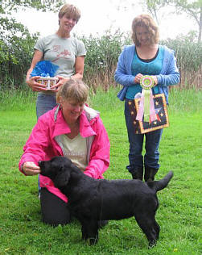 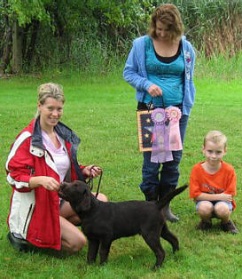
Mona Porter
Heidi Herman & Anne Maynard Tamara, Mike & Payton Karabinus
MORNING MATCH:
Adult Dog Classes:
12-18 Dog
1. Billy – Maryann Czerwinski
AmBred Dog
1. Big – Karen Lolli
Open Dog
1. Pandemonium Hero – Laura & Olin Jennings
Adult Bitch Classes:
12-18 Bitch
1. Folklaur Secret Desire – Laura J Dedering
2. Shar-Jam Vogue – Sharon & James Celentano
3. Shar-Jam Elle – Sharon & James Celentano
4. Sizzle – Maryann Czerwinski
Novice Bitch
1. Berry – Karen Lolli
BBE Bitch
1. Pepper – Hallie Sherck
Open Bitch
1. Autumn – Eve Regalia
Veteran 7-9 Bitch
1. Lacy – Eve Regalia
Veteran 9+ Bitch
1. Missey – Eve Regalia
BEST ADULT IN MATCH – Folklaur Secret Desire
BEST OF OPPOSITE SEX ADULT IN MATCH – Pandemonium Hero
BEST ADULT IN MATCH BEST OF OPPOSITE SEX ADULT IN MATCH
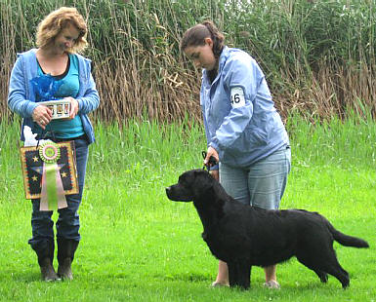 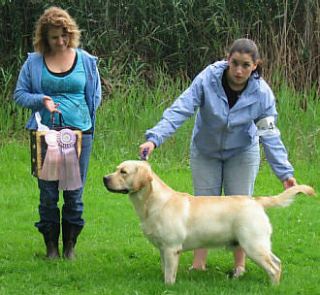
Folklaur Secret Desire Pandemonium Hero
Laura J. Dedering Laura & Olin Jennings
Encore Match Judge: Fabian Negron
Puppy Dog Classes:

3-4 Puppy Dog
1. Porter – Tamara, Mike & Payton Karabinus
9-12 Puppy Dog
1. Deneway’s Turn on Your Hart Lights – Jane Schweizer & Kathie Williams

Puppy Bitch Classes:

3-4 Puppy Bitch
1. Breeze – Kathryn Mines
2. Rainbow – Hallie Sherck
9-12 Puppy Bitch
1. Pandemonium Mellow Yellow – Laura & Olin Jennings
2. Deneway’s Key To My Hart – Jane Schweizer

BEST PUPPY IN MATCH – Breeze
BEST OF OPPOSITE SEX PUPPY IN MATCH – Porter

Adult Dog Classes:

12-18 Dog
1. Billy – Maryann Czerwinski
AmBred Dog
1. Big – Karen Lolli
Open Dog
1. Broadway’s South Pacific – Donna Sevchuk & Maryann Czerwinski
2. Pandemonium Hero – Laura & Olin Jennings

Adult Bitch Classes:
12-18 Bitch
1.Folklaur Secret Desire – Laura J Dedering
2. Sizzle – Maryann Czerwinski
Novice Bitch
1. Berry – Karen Lolli

BEST ADULT IN MATCH – Broadway’s South Pacific
BEST OF OPPOSITE SEX ADULT IN MATCH – Berry
BEST ADULT IN MATCH BEST OF OPPOSITE SEX ADULT IN MATCH
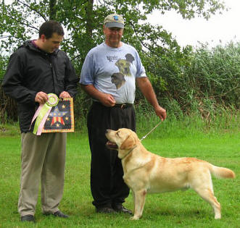 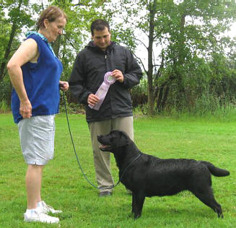
Broadway’s South Pacific Berry
Donna Sevchuk and Maryann Czerwinski Karen Lolli
JERSEY SKYLANDS
LABRADOR RETRIEVER CLUB, INC.
DUES NOTICE

Club Year September 1 – August 31

September 1 is the deadline for JSLRC dues.
Dues will be accepted by mail or at JSLRC meetings only.
BOTH PAGES of this form MUST accompany your payment in order to assure that no errors are made.
BE SURE TO GO TO PAGE 2 AND CIRCLE ANY COMMITTES YOU ARE WILLING TO WORK ON OR CHAIR
Please be sure that all information is complete.

Please mail your dues and form to: JSLRC, Inc.
Sherri Mattheis – Membership Chair
911 Jackson Valley Road
Oxford, NJ 07863

Individual Membership – Dues $25
Individual Member’s Name: ___________________________________________________________________

Household Membership – Dues $40

Household Members’ Names: _________________________________and _______________________________

Address: ________________________________________________________________________________________

Phone: ____-____-______ Cell Phone: ____-____-______ E-Mail(s) ____________________ _________________

Please Complete If Requesting Additional Privileges
NOW AVAILABLE TO ALL MEMBERS WHO QUALIFY
CLUB PARTICIPATION FROM SEPTEMBER 1 THROUGH AUGUST 31 OF THIS PAST YEAR
Member’s Name: _________________________________________________________________________________
Indicate Office held and/or Committee(s) Chaired and/or Committee(s) Worked On:

________________________________________________________________________________________________

________________________________________________________________________________________________
Dates of Meetings attended:
________________ ________________ ________________ ________________ ________________ _____________

Additional Household Member’s Name: ______________________________________________________________
Indicate Office held and/or Committee(s) Chaired and/or Committee(s) Worked On:

________________________________________________________________________________________________

________________________________________________________________________________________________

Dates of Meetings attended:
Page 1 of 2
Members Name: _____________________________________________
JERSEY SKYLANDS LABRADOR RETRIEVER CLUB, INC.
ANNUAL MEMBERSHIP REQUIREMENTS
I. INDIVIDUAL AND HOUSEHOLD MEMBERSHIP:
A. Minimum Requirements for EACH Member:
- Dues must be paid current.
- Must be a member in good standing.
- All new members are subject to a one year probationary period at which time the Board will
review for eligibility for future Additional Privileges. If the Board votes NO at the one year
anniversary, a further one year probationary period may be granted.
B. Privileges:
- Vote
- Hold an Office
- Receive bi-monthly newsletter (One per family)
- Attend meetings, programs & events
- List brags and wins
- Apply for certificates of achievement
- Advertise goods and services in the club newsletter
C. Restrictions:
- Not entitled to list litters or dogs with the Breeder Referral Service
- Not entitled to apply for NJFDC Breeders Directory listing
- Not entitled to apply for competitive awards or plaques

II. ALL MEMBERS MAY EARN ADDITIONAL PRIVILEGES:
A. Additional Requirements for EACH Member:
- Attendance of at least one meeting
- At least one of the following *:
a. Hold an office
b. Chair a major committee
c. Work on two committees - must be two different events and on different days
* SEE CLARIFICATIONS BELOW
B. Additional Privileges:
- List litters or dogs available on the JSLRC Breeder Referral Service
- Have a listing on the JSLRC Breeder Directory website page
- Apply for JSLRC competitive awards/plaques
- Apply for NJFDC Breeders Directory listing
_______________________________________________________________________________________

*Clarifications: The Board has clarified, in reference to membership requirements, what constitutes major and minor committees and fulfillment of those requirements. Members must have actively worked on the committee.

To be considered to have fulfilled the requirements as a board member, you must attend two-thirds of the board meetings held.

Being named on a committee that never meets or is inactive, does NOT meet the membership requirements.
CIRCLE ANY COMMITTES YOU ARE WILLING TO WORK ON OR CHAIR
Major Committees: |  | Minor Committees:
Breeder Referral  CGC/TDI Test  Education  Field Day  Fund Raising  Health Clinic  Match Show  Membership  Newsletter | Obedience  Point Show Coordinator  Point Show Trophies  Point Show Hospitality  Point Show Raffle  Programs  Publicity  Website | Awards  By-Laws and Constitution  Club Equipment  Ethics  Holiday Party  Judges Selection  Meeting Hospitality  Meeting Site  NJ Federation | Nominations  Planning  Policies & Procedures  Sunshine  Therapy Visits
Adopted 07/17/92; Revised 07/28/99, 09/26/01, 09/25/02, 05/28/03, 09/29/04, 07/25/07, 10/03/07
Page 2 of 2
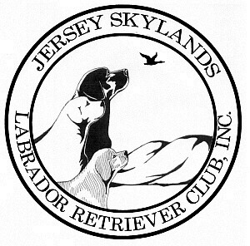

Jersey Skylands Labrador
Retriever Club Newsletter

Leslie Plank
Editor/Publisher
15 Thrush Drive
Smithtown, NY 11787

JSLRC Upcoming Events

Sept. 3 & 4, 2010 JSLRC BACK TO BACK SPECIALTY SHOWS!
Sussex Fairgrounds, 37 Plains Rd. Augusta, NJ
In conjunction with the Newton KC shows
Friday – Judge: Liz Muthard
Puppy Sweeps and Vet Sweeps: Tina Barks (Bellwether)
Saturday - Judge: Manolo Queijiero
Puppy Sweeps and Vet Sweeps: Kathy Sneider VMD (Aquarius)

Sept. 3 & 4, 2010 AKC Responsible Dog Ownership Days
There will be an education table under the Labrador Specialty Tent
where you can discuss or ask questions of Labrador breeders and have access to educational materials. You will have to opportunity to see conformation classes and obedience classes in action.
FMI: Contact PEC Gerie Mines gerie1181@optonline.net

Sept. 29, 2010 Board Meeting: 7:30 PM
ANNUAL Meeting: 8:00 PM
Agenda: ELECTIONS
Pogram: TBA

