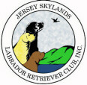 Skywriter 
Volume 2011, Issue 1 Jan/Feb 2011

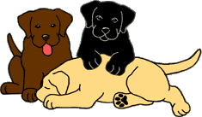
Babes in Skyland
BREEDER REFERRAL LISTINGS
www.jerseyskylandslrc.com/BreederReferral.htm

BABES ALREADY LANDED
6 YEAR OLD BLACK FEMALE – SPAYED
Sugar is extremely sweet and obedient. She would like to be the only dog for someone to love and share their bed with. A place to swim her would be a Plus. Great for an active, retired couple. Up to date with shots.
OFA clearances and Optigen clear.
Sire: Am.Can.Ch. Beechcroft's Study In Black
Dam: Windwood's Mya
Breeder/owner must place some of her dogs due to her own medical problems.
Eve Ragalia 845-883-9143 windwoodkennels@aol.com

14 MONTH OLD YELLOW MALE NEUTERED
Born: November 2, 2009
This is an energetic, playful young boy, who loves to retrieve on land or water. He enjoys being with people and gets along well with other dogs. This young guy would benefit from training and participation in obedience, hunting, or dock diving. He is crate trained and has all his shots, including rabies.
Sire: Ancroft’s Back To The Future
OFA Prelim Hips Good, Elbows Normal, AVCO Nov. 2009, Optigen Normal
Dam: HiView Tiffany At Ancroft
OFA Hips Good and Elbows Normal, AVCO Feb. 2009, Optigen Normal
Ann Degraw 908 362-5514 ancroft@embarqmail.com

7 MONTH OLD BLACK MALE PUPPY
Born: June 24, 2010
Sire: Ch. Kai Den's Power Surge RN TDI
OFA Hips Good, Elbows Normal, Heart Echo Normal; CERF Oct 2009 and Optigen Normal; EIC Normal
Dam: Ancroft Gentleman Prefer Blondes
OFA Good, Elbows Normal, ACVO Feb. 2010,Optg.NBP
Ann Degraw 908 362-5514 ancroft@embarqmail.com

BLACK MALE AND FEMALE PUPPIES
Born: October 10, 2010
Up to date on shots
Sire: MacHenry Daniel Webster
OFA Hips Excellent/Elbows Normal, CERF Dec 2010, Optigen clear
Dam: Holly Golightly XX
OFA Hips Excellent, Elbows normal; CERF Dec 2010 and Optigen normal
Elizabeth Henry 518-589-5843 MacHenry1440@yahoo.com

7 YEAR OLD YELLOW FEMALE
Gem is a lovely soft dog who will do well in many environments.
OFA Hips Good, Elbows Normal, Eyes CERF Clear 2009 and Optigen Normal
Laura Jennings 908-652-1470 cell pandemoniumlabs@yahoo.com

BLACK MALE PUPPIES
Born: January 17, 2011
Sire: Can. Ch. Folklaur Jolly Gentleman Of Pandemonium
OFA Hips good, elbows normal, Heart echo normal, CERF Feb 2010, Optigen Normal
Dam: Pandemonium Charisma
OFA Hips good, elbows normal, CERF Feb 2010, Optigen Normal
Laura Jennings 908-652-1470 cell pandemoniumlabs@yahoo.com

CHOCOLATE PUPPIES
Born: January 17, 2011
Sire: Am.Can. Ch. Venetian's Copy That
OFA Hips Excellent, Elbows Normal, Heart Echo Normal, Optigen PRA Normal/Clear, Eyes CERF Jan. 2010
Dam: Walkabout Gingerbred's Lucy
OFA Hips Good, Elbows Normal, Heart Echo Normal, Optigen PRA Normal/Clear, Eyes CERF 2010
Dottie Martin ginspin@embarqmail.com
The breeders listed in our referral service are members in good standing of JSLRC, but under NO circumstance does JSLRC guarantee the services of said members. The buyer should review all contracts directly with the breeder.
Full members, eligible for additional benefits, wishing to list a litter in the club newsletter and on the website must do so in writing ON THE CLUB FORM.

Please send info ON THE CLUB FORM to:
Laura Dedering - JSLRC Breeder Referrals
by email: jslrcinc@epix.net
by Fax: 610-599-7723
by mail: 98 Ramblewood Dr.
Bangor, PA 18013-5601

2010 – 2011
JSLRC Officers and Board:

President: Donna Forte

Vice Pres: Sharon Celentano

Secretary: Sherri Mattheis
911 Jackson Valley Road
Oxford, NJ 07863
(908) 689-5865

Treasurer: Laura Dedering

Directors:
1 Year– Donna Sevchuk 2010-2011
2 Year - Laura Muirhead 2009-2011
2 Year – Karen Lolli 2009-2011

Newsletter Staff:
Newsletter Editor and Publisher:

Leslie Plank
Smithtown, NY
631-724-7593
forestwood@dellmail.com

Contributing Editors
and Publishers:

Lisa Grasso
Merrick, NY
516-456-9400
lisag22@optonline.net

Gerri Kennedy-Youngblood
35 Eastview Drive
New Fairfield, CT 06812
203-746-9432
snugharborlabs@sbcglobal.net

SKYWRITER is a publication of the Jersey Skylands Labrador Retriever Club, Inc. published six times a year with deadlines on the 15th of Feb, Apr, Jun, Aug, Oct and Dec. Contributions in the form of articles, news comments, wins, litter, and other items of interest to the membership are encouraged. Opinions expressed are those of the individual authors and not those of the JSLRC either in whole or in part. The Editor reserves the right to edit materials in the interest of space, literary clarity, good taste or timeliness. All deadlines will be strictly enforced. Subscriptions are available to non-members for $12.00 per year from JSLRC, through the Publisher.


By Fran Pidgeon

No new members to report this month.

~
Committee Chairs are reminded to contact new members and get them involved in JSLRC activities.

Anyone interested in becoming a member of JSLRC can contact our Membership Chair for procedures and a membership packet.

Call or write to:
Fran Pidgeon
JSLRC Membership Chair
973-726-8650
ragdollkitties@embarqmail.com

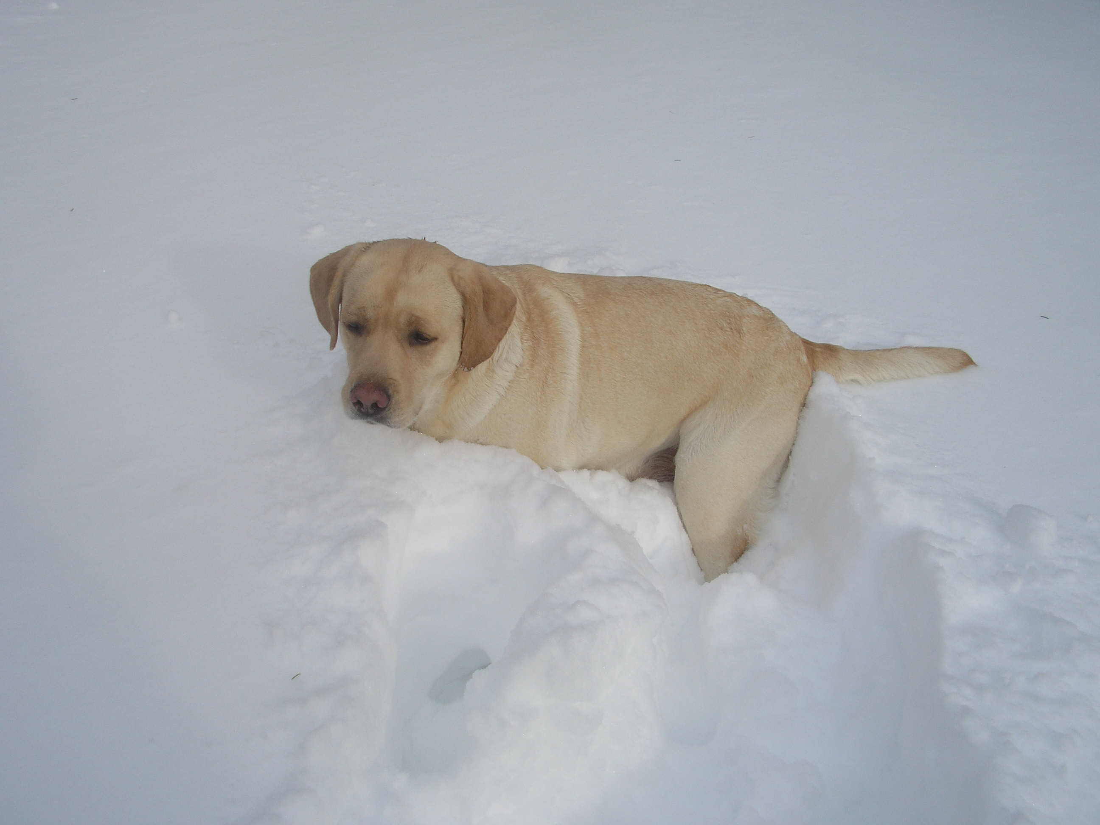

Table Of Contents

Canine Learning Exp. Pg 3

Epilepsy Research Pg 4

NJFDC Pg 8

Awards Description Pg 9

Awards Applications Pg 10

PRESIDENT’S MESSAGE

Hello All,

Hope this finds everyone well and I hope you all enjoyed your holidays.

I want to recap what’s been happening and talk about what’s coming up, but I also want to remind members, if you need to disseminate information to club members then send an email with all the details to Jenn Simpson, she handles our internal communications. However if you need information to get out to the general public i.e. advertising an upcoming event, then send your email to Lisa Grasso. Both their emails are in the membership list that Fran Pidgeon set out, if you didn’t get that list contact Fran or myself.

Sherri Mattheis did a fantastic job on our booth for the LVKC’s Canine Learning Experience. I want to thank her for all her hard work, the booth looked great and there were lots of interesting facts about the history of our breed. Photos are up on the Events page of the website.

The Winter Health Clinic at Blairstown Animal Hospital was a HUGE success! Many thanks to Dr Leal for offering us his facility. Every year we seem to do more than the year before and this year was no exception! THANK YOU Dottie Martin, Sherri Mattheis, Janice Mines, Cathy Murch, Stephanie Forte and Phil Hess for all your hard work, you all kept things moving throughout the day. Thanks too to the other members that helped, Hallie Sherck, Andrea Skarra and Desiree Cougle.

Continued on page 3

Stars of the Sky



Rockycreek's Jewel Of The Nile
Sand and Sea KC 1 – Qualified Rally
Sand and Sea KC 2 – Qualified Rally
Breeder/Owner/Handler – Gerie, Janice and Kathy Mines

Rockycreek Bittersweet Drambuie
Boardwalk KC- Best BBE
BEST BBE IN SHOW!
Breeders: – Gerie & Kathy Mines
Owners: Kathy Mines & Susan Brownell

Forestwood’s Rox Star Girl
Lehigh Valley KC –WB/BOW/BOS
Clearwater KC – RWB
Inverness KC- WB/BOW
3 Point Major!
Breeder/Owner: Leslie Plank

Am/Can. Ch. Brookberry’s Perfect Impression
Lehigh Valley KC – Sel Dog
Sand and Sea KC 1 – Qualified Rally with score of 96
Sand and Sea KC 2 – Qualified Rally with score of 94
Breeder/Owner/Handler: Donna and Stephanie Forte

Cedarmarsh's Makalapua
Sand and Sea KC 2 – WB/BOS
Big Apple Sporting - RWB
Breeder/Owner/Handler: Sherri Mattheis

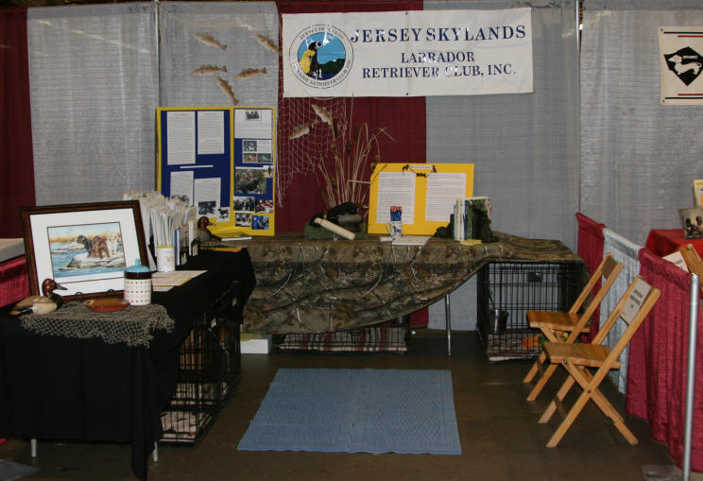

Canine Learning Experience Booth 2011

PRESIDENT’S MESSAGE Continued

February 20th is another Rally training session. The flyer is on the website, we do have a limit for the number of attendees, so make sure you send your from into Fran if you’re interested…hope to see you there.

Get your award applications into Desiree, they will be presented at the March meeting. We’re also hoping to have a presentation on stem cell therapy, either at the March meeting or the May meeting, so stay tuned….

Last but not least, the Trophy Donation List was sent by email so don’t forget to pick the class or classes you want to sponsor and get your check into the treasurer! Thanks in advance for your generosity in making our Trophy Table great!

That’s all I can think of for now.

Be well!

Donna

Canine Learning Experience 2011 Report

The Canine Learning Experience, sponsored by the Lehigh Valley Kennel Club was held on January 29, 2011. This years theme for the breed booths was “Back to the Beginning (Origin, History, Bred For)”. We had breeder’s on hand to answer questions as well as handouts on acquiring a puppy, health issues and training. Our booth was extremely busy with lots of visitors stopping by to say hello to the puppies and dogs that were at our booth. I would like to thank Donna and Stephanie Forte, Cathy Murch and Donna Sevchuk for all of their help.

Sherri Mattheis, Canine Learning Experience Chairperson

Editors Note: The following article is reprinted with permission from the author.

EPILEPSY RESEARCH

In September, 2008 my friend Maggie Black and I were driving home from the Huron River LRC specialty show when Maggie said, “I’m going to be show secretary next year, and YOU are going to do something.”

That would be the 2009 Mid-Jersey specialty. Well I had a major case of burnout after 2003 when I had run a health clinic, a match show, a Hutch seminar, and finished up my 2nd year as treasurer. I had been sitting on my hands since then and only attended a couple of meetings when compelling programs were given. So, my reply was, “I am not!”

“Yes you are!”

“No, I’m not!”

“You are too!”

That’s what you think!”

“Yes you are. Just let me know what you are going to do.”

Maggie was going to be out of luck, and that is all there was to it. A couple of weeks later as I was straightening up the garage, I stood looking at the 5 flying saucer puppy pans when suddenly it popped into my head. That’s it! A garage sale to benefit epilepsy research! I could ask club members and exhibitors to bring their unwanted dog items and I could sell them at the specialty.

Epilepsy has been a problem for me. In the ‘90’s I produced 2 back-to-back litters with the same stud, almost one year apart. When the first litter turned 18 months, the pup I kept had a seizure. A couple of months later, I got a call from a distraught owner, telling me her dog started having seizures too. If you have ever seen a dog seizure, you know what a terrible experience it is. And the worst is when a child has to see his or her dog seizing. With two dogs seizing and knowing there was a second litter out there, I was in a panic. But there was nothing I could do at this point. I didn’t want to frighten the owners of the other pups, so I had to wait it out. Every year on their birthdays, I called all the owners to say “happy birthday” and ask how the dogs were. In time I was to learn that 5 out of the 17 puppies had seizures. Ten years later, seizures struck again. The original bitch was not in this pedigree. It seemed, in spite of all my efforts, the epilepsy gene had come back to haunt me

I felt so helpless all those years, now maybe there was something I could do. I went online and started looking to see what I could learn. One thing that I knew I wanted to do was to give the proceeds of the garage sale directly to the researchers. I did not want one penny to be spent on administrative costs. There were a number of teams doing research, and some of them at different vet schools seemed to be cooperating. They were asking for help from the dog community. That sounded good to me.

I picked up the phone and called the number for Gary Johnson, DVM, PhD, at University of Missouri, College of Veterinary Medicine. My call was answered by Liz Hansen. Liz is the Project Coordinator.

Liz was very helpful and willing to answer my questions. Could they accept direct contributions? “Yes.” That was a good start. I was absolutely amazed by the rest of what Liz had to say.

As a minimum to initiate a mapping study, UM needs to have 25 sibling pairs in which one sibling has seizures and the other does not. Family groups are also important, so wherever an epileptic dog has appeared, it is useful to send samples from the affected, plus as many of the normal siblings, parents, and grandparents as possible. The funding needed to conduct the initial mapping study runs between $15,00-20,000.

Currently UM has DNA from 38 seizing labs, but very few with DNA from their normal siblings. Samples from random normal dogs are not needed, because UM has DNA from over 5000 Labradors through work with Guide Dogs for the Blind and Guiding Eyes for the Blind. Sibling pairs and family groups where epilepsy has appeared are the key to being able to map epilepsy in this, or any breed. There are likely to be many forms of inherited epilepsy in dogs. There have been over 30 different forms identified in humans and laboratory mice.

Liz said, when they started the epilepsy research project, they assumed there would be many samples from the popular Labrador Retriever. To their surprise, that was not to be the case.

The Greater Swiss Mountain Dog breeders have gotten behind epilepsy research. By March, 2009 they had blood from over 1200 dogs, 63 of which are affected. An initial mapping run has already been completed for GSMD’s, and the data is in the process of being analyzed.

The researchers at University of Missouri are cooperating with other researchers in the USA and also in Finland, France and England. Most of the mapping has been done in Finland and France so far, but in July UM will have the new SNP chip and will be capable of doing the mapping studies on campus. Other breeds that have some mapping data already being analyzed include Saint Bernards, Standard Schnauzers, and Chinooks. Ten other breeds are ready to map, and will be evaluated in the coming months.

If the lab community, with our huge number of dogs, gets behind this we could have well more than the initial 25 pairs in no time at all. 25 pairs is next to nothing. As with everything else, the trick is to do it!

After our conversation, I had to wonder why they had so few blood samples submitted. That is when I read the literature they have online. I didn’t have to read very far before one thing jumped right out at me. “Complete families are critical to locating specific genes and markers. Wherever possible, submit samples from all siblings, both parents, and all available grandparents.” Good grief! A typical litter would have 8 puppies, 2 parents, and 4 grandparents. 14 dogs! I figure, if I hadn’t talked to Liz first, I probably would have stopped right there. Can you imagine rounding up all those dogs, collecting the blood, and shipping it to Missouri? I can’t. I think only very, very few people would be able do that. While it might be the ideal, it is not something most people could or would do.

So let’s state it one more time.

They need 25 sibling pairs in which one dog has seizures and the other does not have seizures to run the initial mapping study.

So what do you have to do to participate?

- Round up a sibling pair. Owners with non-seizing dogs are usually willing to participate, but have little motivation. I had one such owner who needed a little extra help. They forgot all about it when they took their dog to the vet. I ended up going to their house, picking up the dog, and taking her to my vet one day when my girl was going in for a progesterone test. Everyone was happy and that gave me a sibling pair. If you can get your hands on other related dogs, great.

- Collect the blood. The ideal plan is to get 2 siblings, plus any relatives, collected at once. That way you can put all blood samples in the same package and save on shipping costs. Blood can be kept a couple of days in the refrigerator, so you can bundle blood collected a couple of days apart. So far I have heard of only one vet who charged for the blood draw and the fee was very small. Be sure to print out the sample handling page (see below) and take it with you to the vet.

- Package the blood. Ask your vet to have a freezer pack ready when you come for the blood draw. Vets get freezer packs with vaccine shipments and always have plenty to spare. The blood is sent in several tiny purple top tubes. Each tube is labeled with the dog’s call name and the owner’s last name. You can wrap the tubes in a couple layers of paper toweling so they do not come in direct contact with the freezer pack. Next, start wrapping the pack and the blood with a single layer of newspaper. Keep adding layers to make a nice cocoon that will fit snugly in the box. Newspaper is an excellent insulator. Your vet may have boxes you can use. The boxes do not have to be large.

- Shipping the blood. The blood must be sent overnight. If you don’t get carried away with the box, the cost will be around $30-40. You may not want to trust the USPS to deliver it on time. I’ve had really great experience with FedEx and their online tracking system gives blow-by-blow updates of a package’s journey. You can give Liz’s email address as the recipient so she will be informed when you drop it off and when it arrives. One other tip – if the weather is warm, take the package to be shipped late in the day as possible. That way it will be sure to keep cool for the duration.

- Paper work. Yes, I know. We don’t really like this part very much, but you can do it. There is a simple form for each dog that is put in the package with the blood sample. There is an online form that is filled out ONLY for the dogs that have seizures. The form asks for some things only the breeder can answer and other things only the owners can answer. Because of that, I print the form and highlight the questions that only the owner could answer. I then ask the owner for that information and fill out the online form out myself. I figure as the breeder, I am the one who has most at stake in doing this. If you prefer, you can send the printed form via snail mail.

- One last suggestion. When the blood samples from your sibling pair arrives at UM, call Liz or send her an email ( HansenL@missouri.edu ) alerting her to the fact that another sibling pair is in their possession.

So yes, there is some work involved, and some expense too. But what a small price to pay when a test will be developed with some help from us, the breeders.

Do you have access to a sibling pair, and maybe relatives too? Please help. With your cooperation, the researchers will help us so that we need never produce seizing dogs again. This is so worthwhile!

Here are links that will give you the information you need to participate.

http://www.canine-epilepsy.net/Docs/DNAsampl.pdf This one is supposed to be sent in with the blood sample. I had to send it in separately for one dog & that was OK.

http://www.canine-epilepsy.net/Srvy_Ins.htm This form is to be filled out ONLY if the dog has seizures. You can complete it online or print it out and mail it to UM.

http://www.canine-epilepsy.net/Docs/DNAhowto.pdf This one talks about what they are looking for. Don’t get hung up on the part about entire families. Think pairs!!! Additional family members are icing on the cake.

http://www.canine-epilepsy.net/Docs/SampHand.pdf This one talks about the blood collection & has the address for sending it.

http://tulgeywoodlabs.com/pages/PackingSamples.pdf This page gives step-by-step instructions for packing up the samples and shipping them.

The Mid-Jersey board gave the Garage Sale a big thumbs up, and it was held at our specialty on October 15th & 16th, 2009. So, while you are at it, how about holding a “garage sale” at your club’s next specialty. You can contact me and I can give you some hints about running a sale.

If we all cooperate, we can beat epilepsy. Your contribution of blood samples is what is needed. You will feel proud to have made a significant contribution to eliminating epilepsy in Labrador Retrievers.

Joan McInnis
Tulgeywood Labradors
jmcinnis@oncore.com
732 842-6961



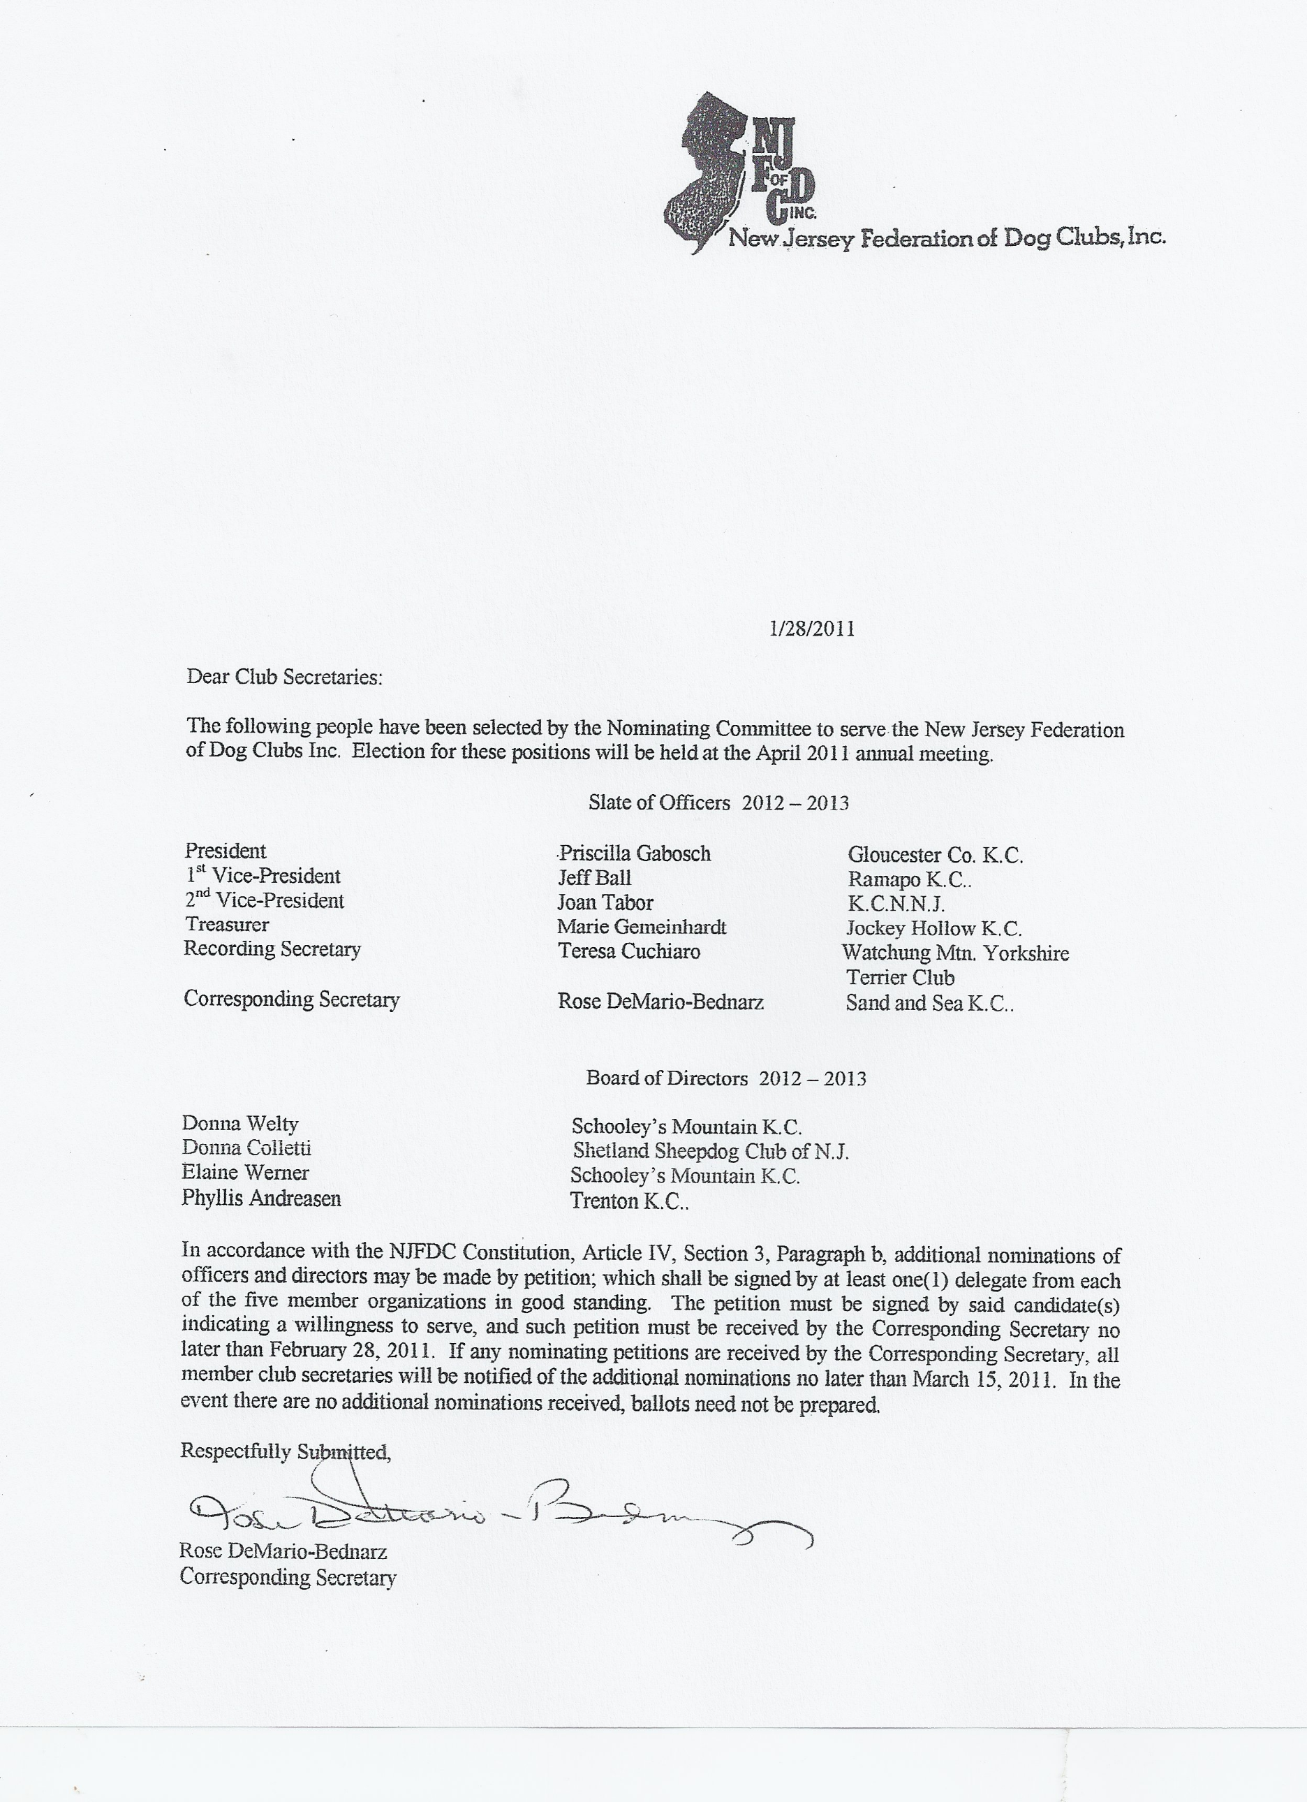

JERSEY SKYLANDS LABRADOR RETRIEVER CLUB, INC.

AWARDS DESCRIPTION
Members are responsible for applying for their awards with the required verifying documents. Certificate awards are available to all members, but competitive awards are available only to full members who have earned additional privileges. Awards cover achievements that were completed during the previous calendar year (i.e. the award year). In the following, service dogs include guide dogs, hearing dogs, handicapped-assistance dogs, police dogs, narcotics or bomb squad dogs, search & rescue dogs, or others trained and employed by organizations as deemed acceptable. Canine Good Citizen and Therapy Dog Certificates are not eligible for awards.
COMPETITIVE AWARDS:
One award available to each sex in each category. Copies of the AKC Gazette Awards pages are required.

Top Specials Dog/Bitch: Highest number labs defeated as a finished champion during the award year as a BOB or BOS only.
Top Winners Dog/Bitch: Highest number of Labs defeated from the classes during the award year, as a winner, BOW, BOB, or BOS only. For BOW, all class dogs of both sexes are counted. For BOS count all the dogs the same sex as your dog and any specials of the same sex. For BOB all the dogs from both sexes and all specials are counted.
Top Junior Dog/Bitch: Highest cumulative number of Labs defeated by dog/bitch under two years of age at the time of the placements, as a Winner, RW, BOW, BOB, or BOS only. The wins may be from prior years through the award year. The dog/bitch need not be a finished champion. The award may be applied for more than once for the same dog but no later than the year following the dog’s second birthday. Dogs defeated are calculated the same as for Top WD/WB above. When counting reserve, count all the dogs the same sex as your dog minus the WD/WB
Top Obedience Dog/Bitch: Highest average of all qualifying scores in A classes or Novice B classes for title completed during the award year, or highest average of all scores in Open B or Utility B attained during the award year.

NEW TITLE CERTIFICATE AWARDS:
An award for completing one of the following titles during the award year; they may have begun earlier. Foreign titles are included. A copy of the official certificate or AKC Gazette Awards page is required.
New Champion New Obedience Title New Agility Title
New Field Title New Tracking Title New Rally Title
New Hunting Title New Working Certificate
Outstanding handling achievement for dogs handled to ALL points or qualifying scores for the title will be added to the certificate for all of the above as follows:
Owner/Handler Breeder/Handler Breeder/Owner/Handler

OUTSTANDING ACHIEVEMENT CERTIFICATE AWARDS:
Presented for achievements that are truly outstanding. A copy of the AKC Gazette Awards page or a letter of satisfactory performance from a service organization is required.
Conformation: Received three five-point majors; four four-point major; five three point majors.
Obedience: All qualifying legs with scores of 195 or better without NQ’s; or a High in Trial.
Hunting: Received all qualifying wings without an NQ.
Field: Any placement at a field trial.
All Around Retriever: Must be a Breed Champion, and a CD in obedience or higher, and a JR Hunter or higher, or a Tracking Title holder or higher. Only the last title must be completed during the award year.
All Around Producing Dog: A minimum of four get achieving titles during the award year including titles above plus graduated service dogs.
All Around Producing Bitch: Same as for Dog, except a minimum of two get.
Community Service (Person): The owner has a minimum of four therapy visitation, four educational programs with dogs, or one search and rescue mission.

JERSEY SKYLANDS LABRADOR RETRIEVER CLUB, INC.
AWARDS APPLICATION – 2010 ACHIEVEMENTS

OWNER:_________________________________________

DOG:____________________________________________

ADDRESS: ________________________________________________________________
MARK THE DESIRED COMPETITIVE AWARD AND ENTER THE NUMBER
Top Specials Dog ______ Top Specials Bitch ______ No. Labs Defeated ______
Top Winners Dog ______ Top Winners Bitch ______ No. Labs Defeated ______
Top Junior Dog ________ Top Junior Bitch ________ No. Labs Defeated ______
Top Obedience Dog__ ____ Top Obedience Bitch _____ Highest Average ______
*ATTACH COPY OF AKC GAZETTE AWARDS PAGE OR PRINTOUTS FROM AKC WEBSITE*

MARK THE DESIRED CERTIFICATE AWARD FOR NEW TITLE
*Title must have been completed in 2010*
Champion ____________ Obedience ____________ Hunting Title ____________
Tracking ______________ Field Title _____________ Working Certif __________
Agility ________________ Rally _______________

Handling Achievements:
Owner/Handler _______ Breeder/Handler _______ Breeder/Owner Handler ______
***ATTACH COPY OF OFFICIAL CERTIFICATE OR AKC GAZETTE AWARDS PAGE ***

MARK THE DESIRED CERTIFICATE AWARD FOR OUTSTANDING ACHIEVEMENT
Conformation____________ Field _____________ All Around Retriever __________

Obedience ____________ Hunting ___________ All Around Producing Dog _______

Community Service (Person) ____________________ All Around Producing Bitch____

*****ATTACH COPY OF OFFICIAL CERTIFICATE, AKC GAZETTE AWARDS PAGE OR LETTER FROM SERVICE ORGANIZATION*****

Return your completed application by March 13, 2011 to:

Desiree Cougle 7 Birch Lane, Hackettstown, NJ 07840 908-852-2082 desiree.cougle@verizon.net ***Awards to be presented at the March meeting***



Jersey Skylands Labrador
Retriever Club Newsletter

Leslie Plank
Editor/Publisher
15 Thrush Drive
Smithtown, NY 11787

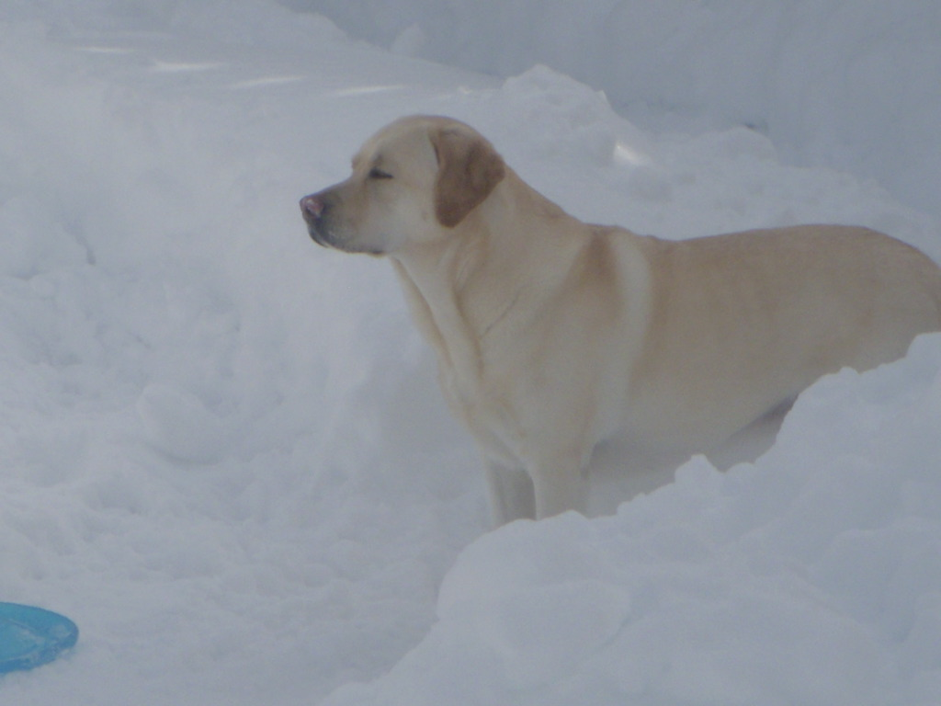

JSLRC Upcoming Events

Feb. 20, 2011 RALLY FUN DAY! JSLRC MEMBERS ONLY (see flyer on website)
11:00 AM – 1:00 PM
FMI: Contact Fran Pidgeon 973-726-8650
March 30, 2011 Board Meeting: 7:30 PM
General Meeting: 8:00 PM
Agenda: Annual Awards
Program: TBA

April 27, 2011 Board Meeting: 7:30 PM

